Western Mathematics Exams

School Name

Yearly Examination
2016
Year 10
Advanced Mathematics Course

Solutions
Year 10 |  | WME Solutions  Advanced Mathematics Yearly 2016 | Non Calculator
Section 1 Short Answer Section
ANSWERS
No. | WORKING |  | ANSWER
 | 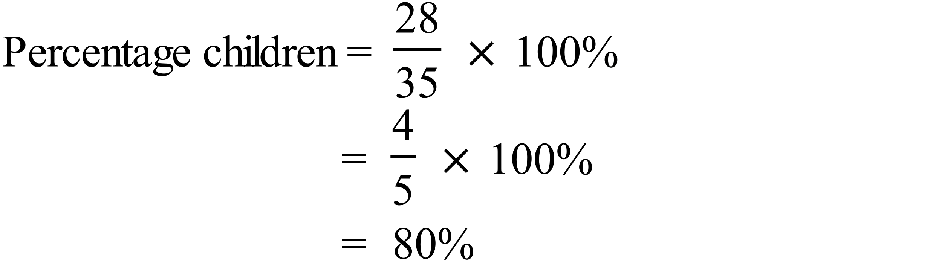 |  | 80%
 | 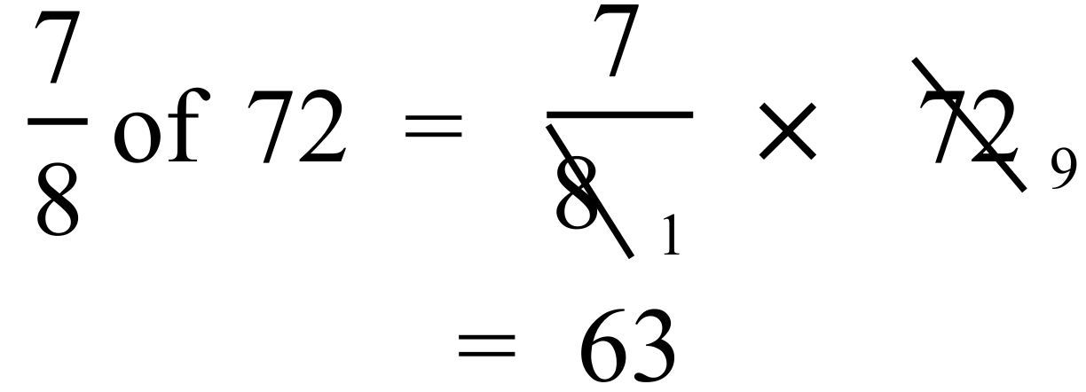 |  | 63
 | 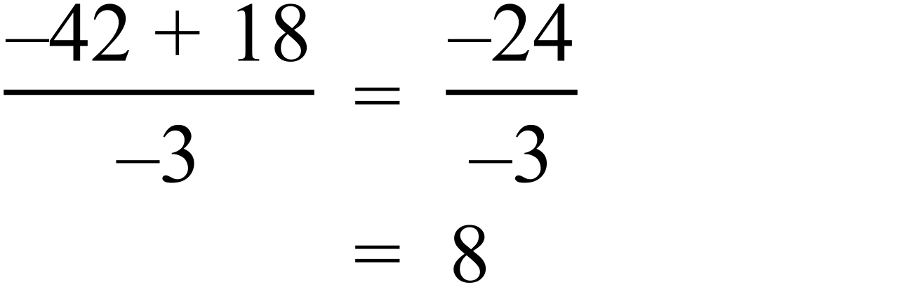 |  | 8
 | 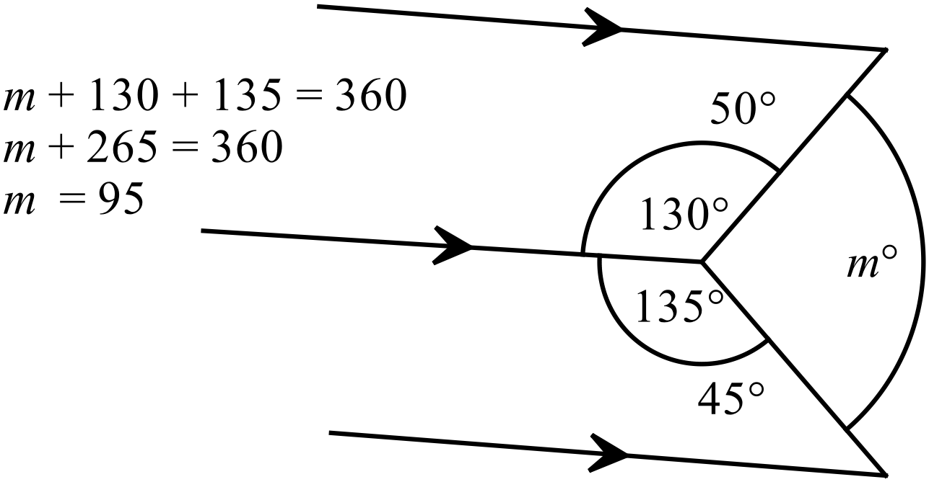 |  | m = 95
 | 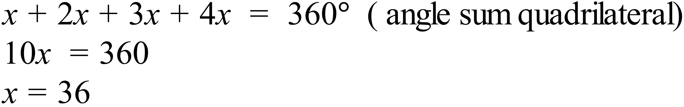 |  | x = 36
 | Glasgow is 9 hours behind, so Sydney is 9 hours ahead of 1:45 pm, which is 10:45 pm on Saturday 12th November. |  | 10:45 pm on Saturday 12th Nov
 | 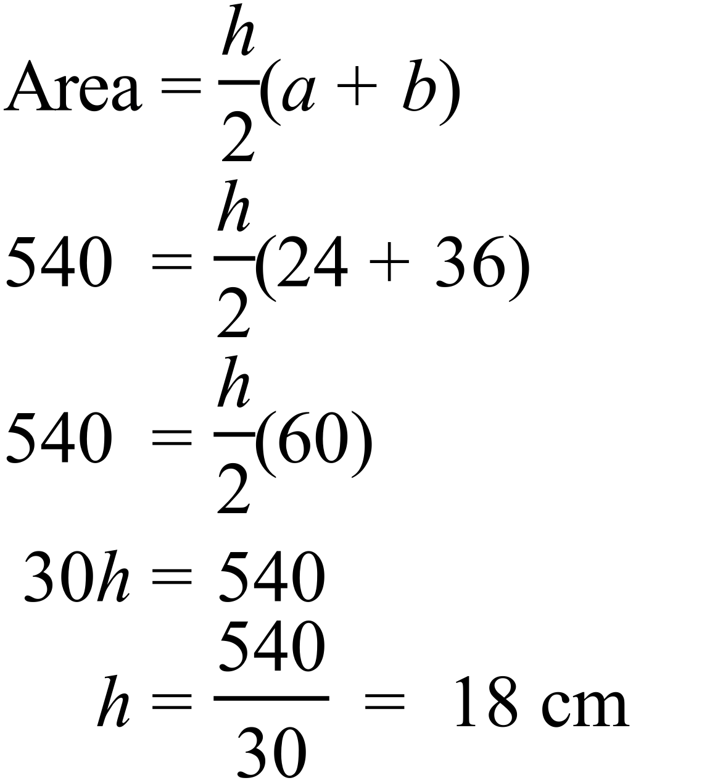 |  | 18 cm
 | 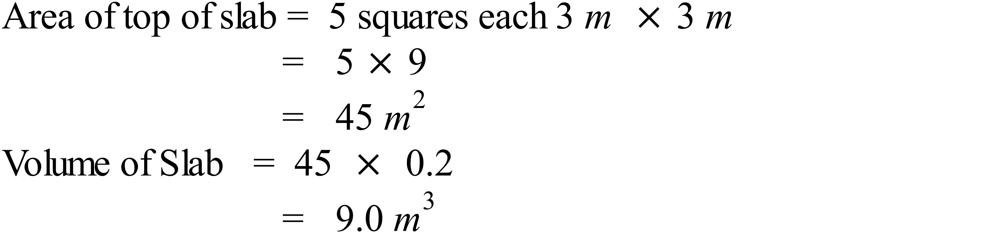 |  | 9 m²
 | 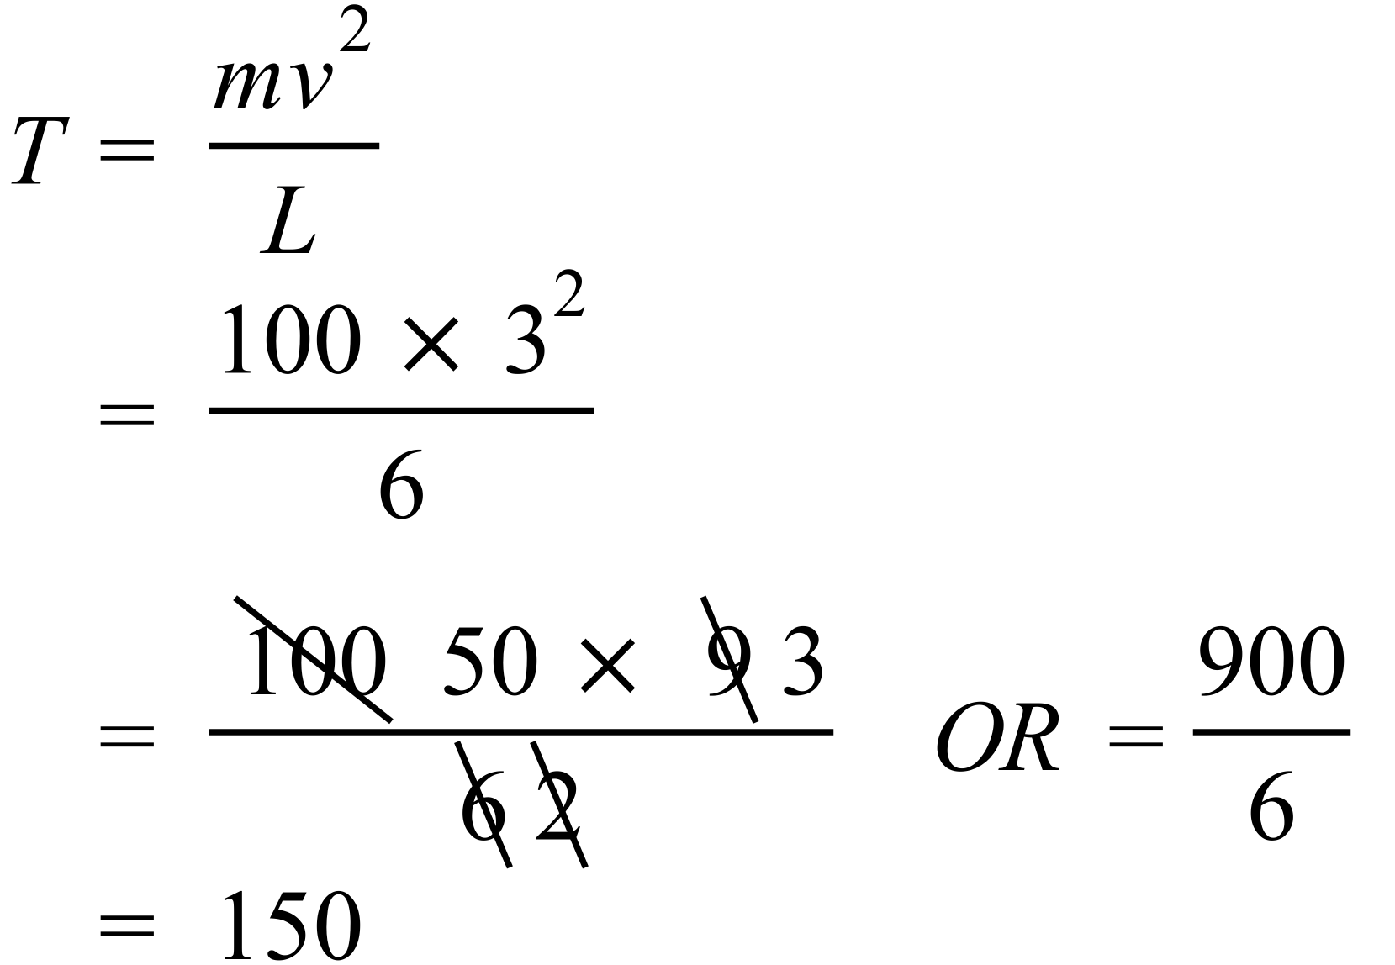 |  | 150
 | 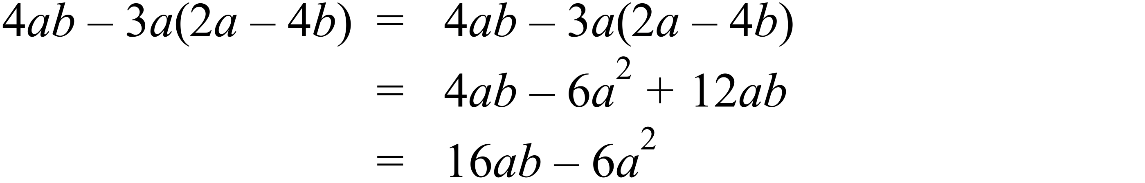 |  | 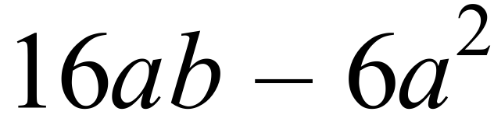
 | 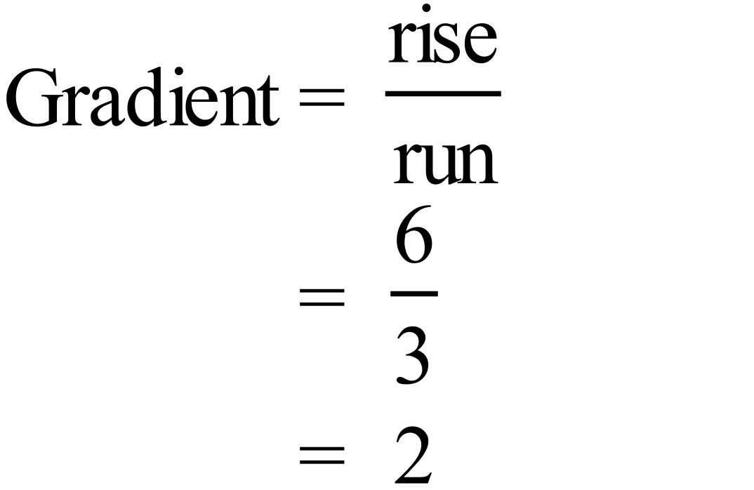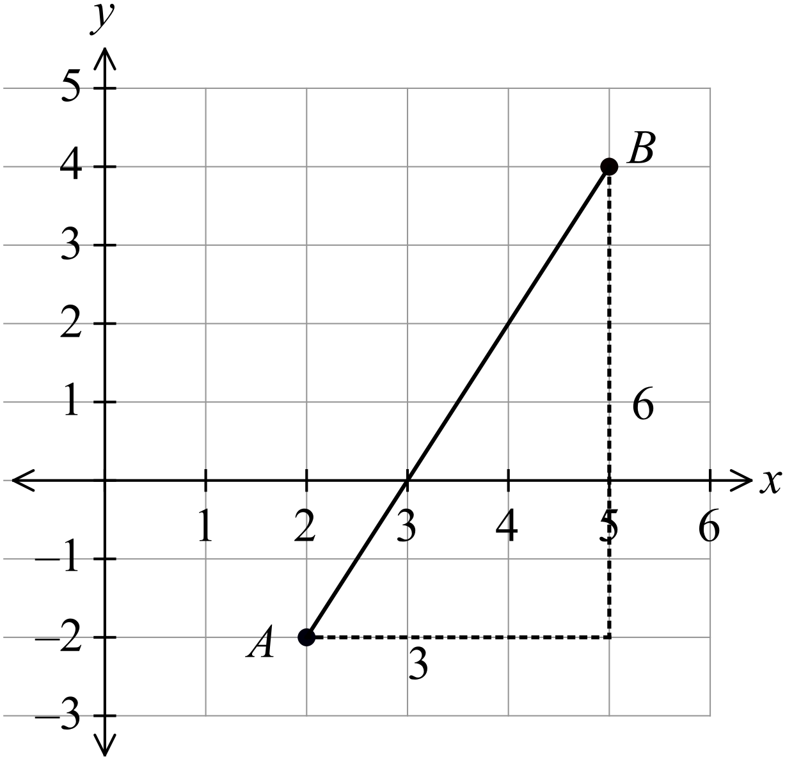 |  | 2
 | 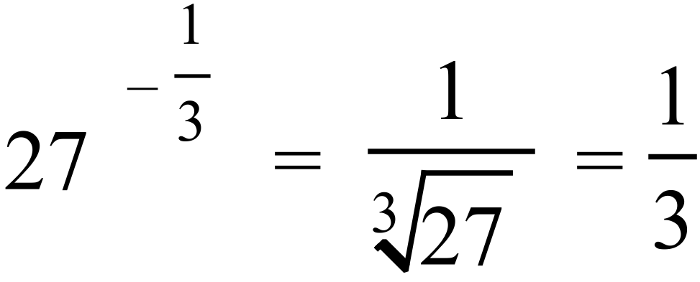 |  | 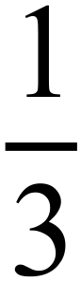
 | 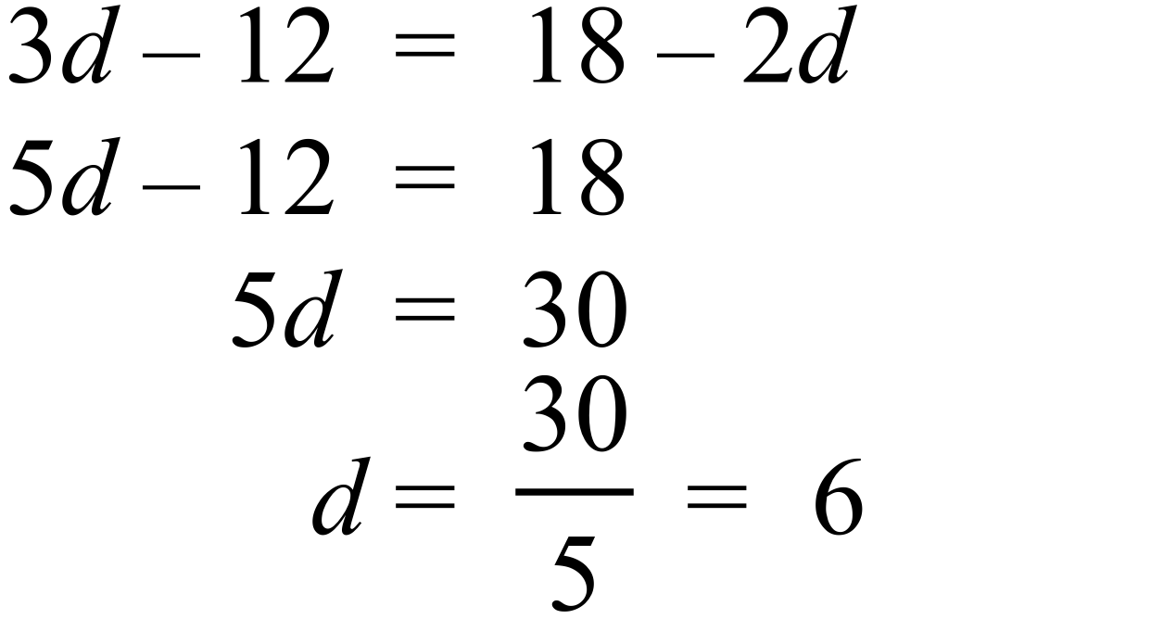. |  | d = 6
 | 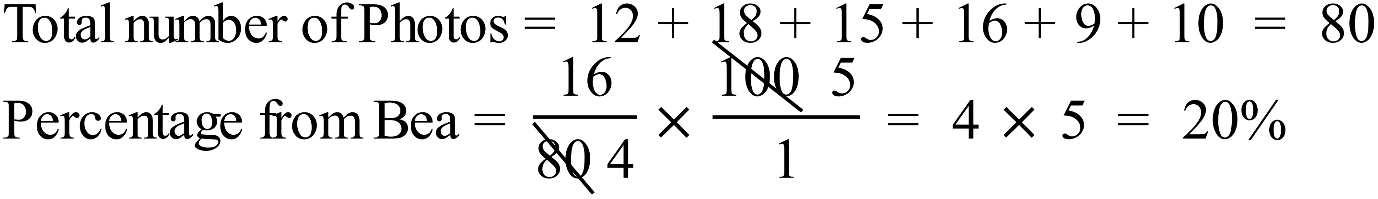 |  | 20%
 | 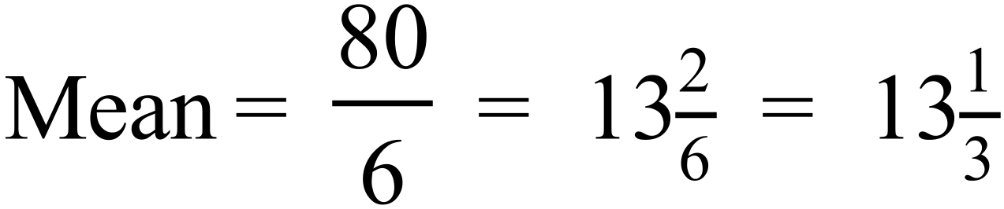 |  | 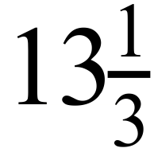
 | 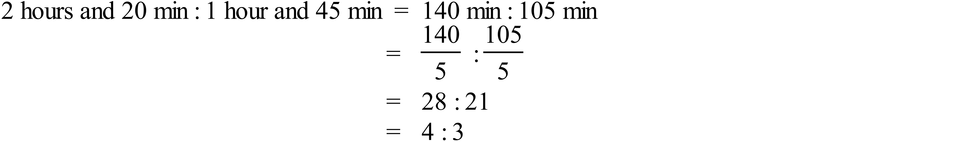 |  | 4 : 3
 | Midpoint of interval joining P (-6, 10) and Q (4, 5)  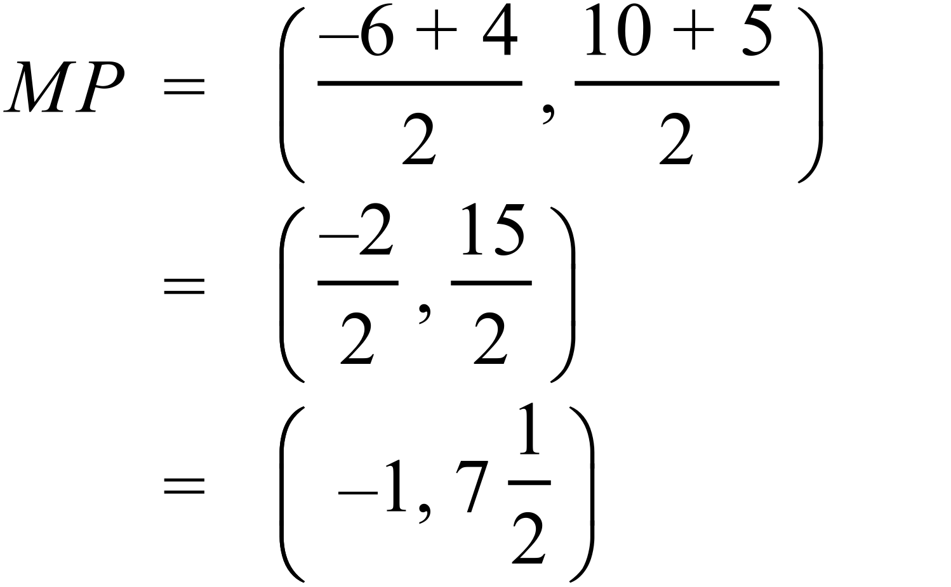 |  | 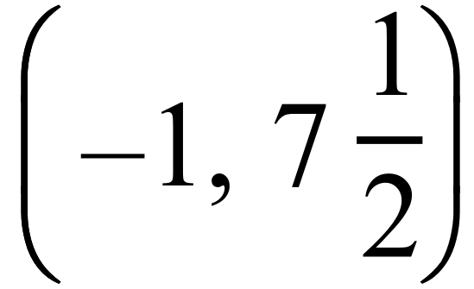
 | 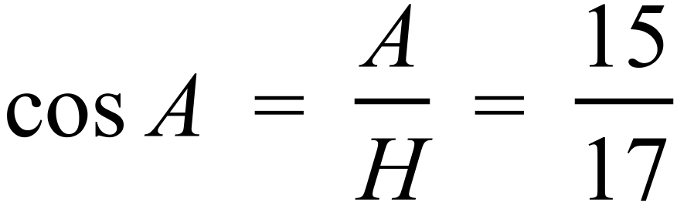 |  | 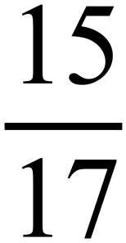
 | 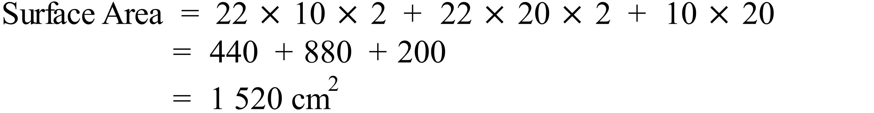 |  | 1 520 cm²
 | 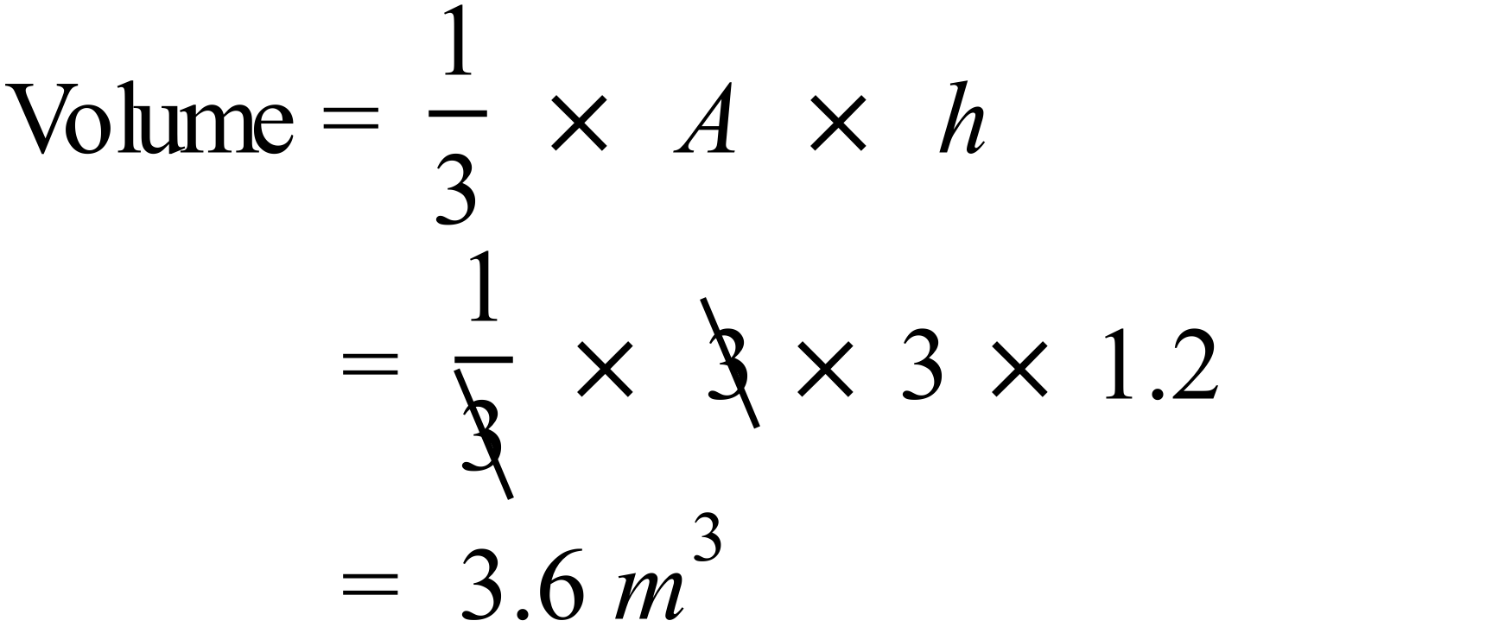 |  | 3.6 m³
 | 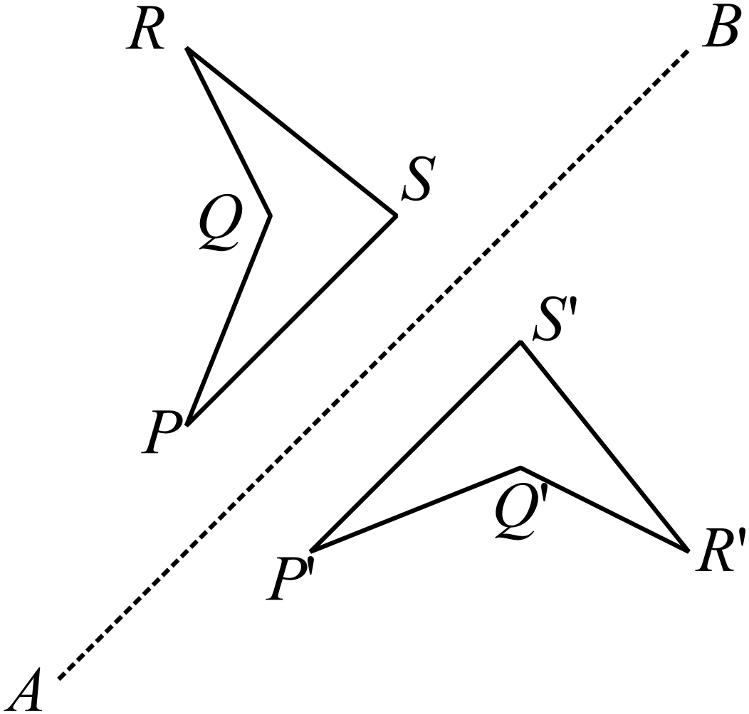 |  | The image P’Q’R’S’ is drawn accurately.
 | 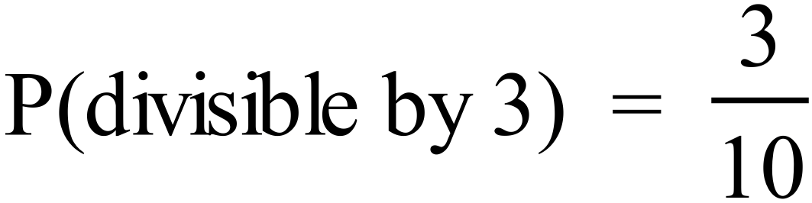 |  | 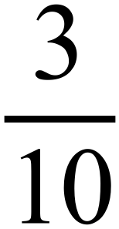
 | 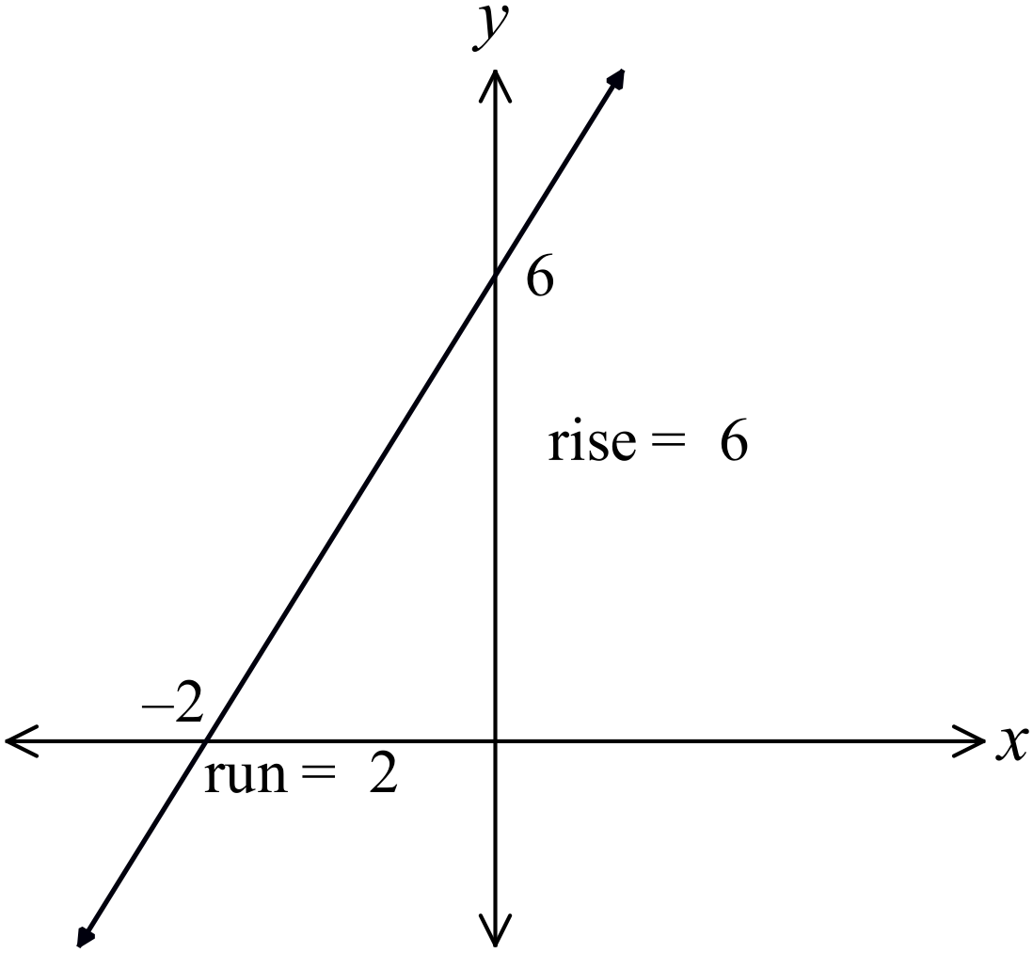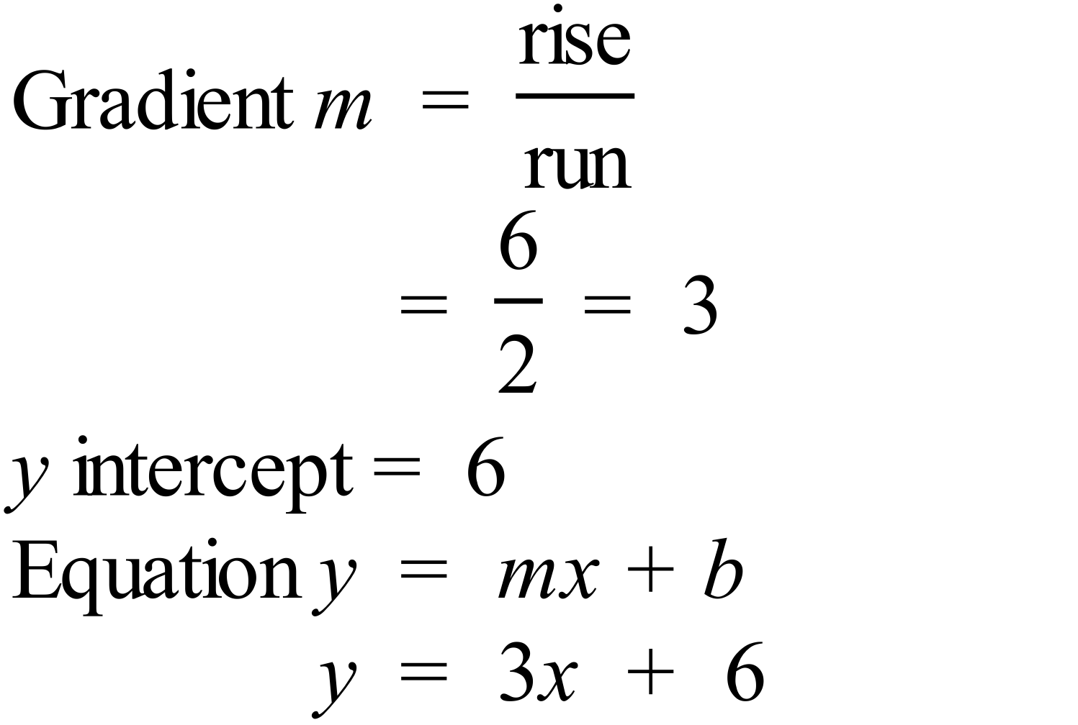 |  | 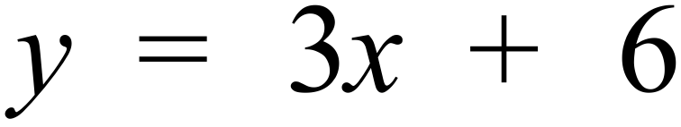
 | 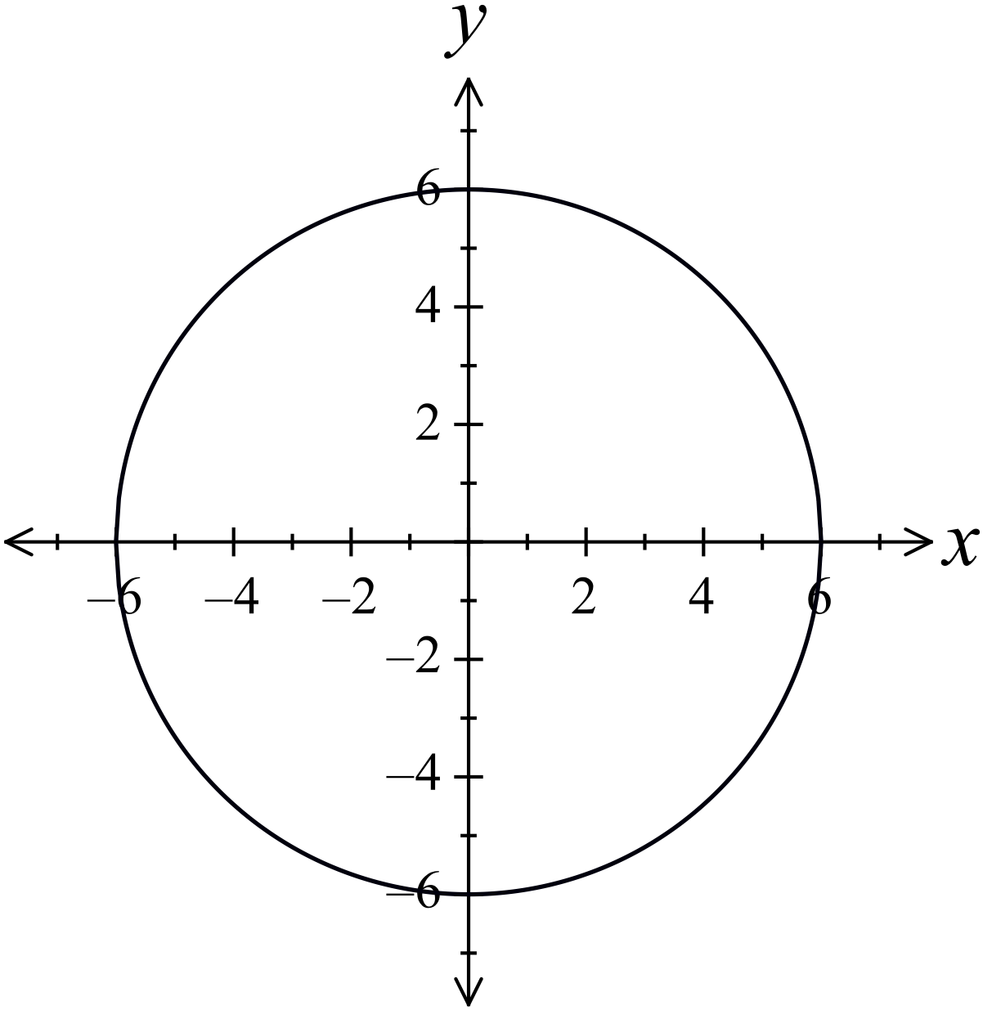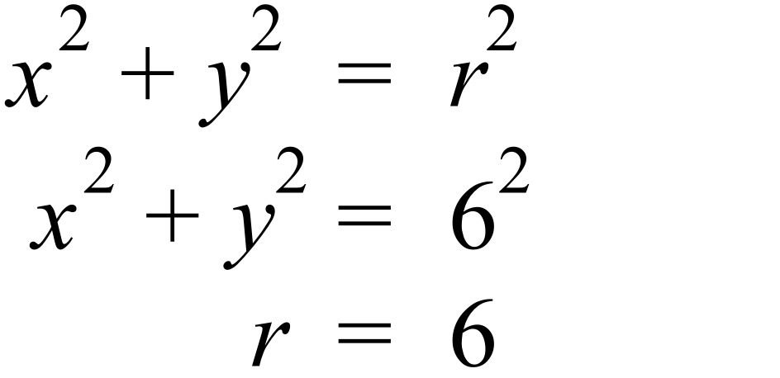  Centre is the origin. |  | See the graph.
 | 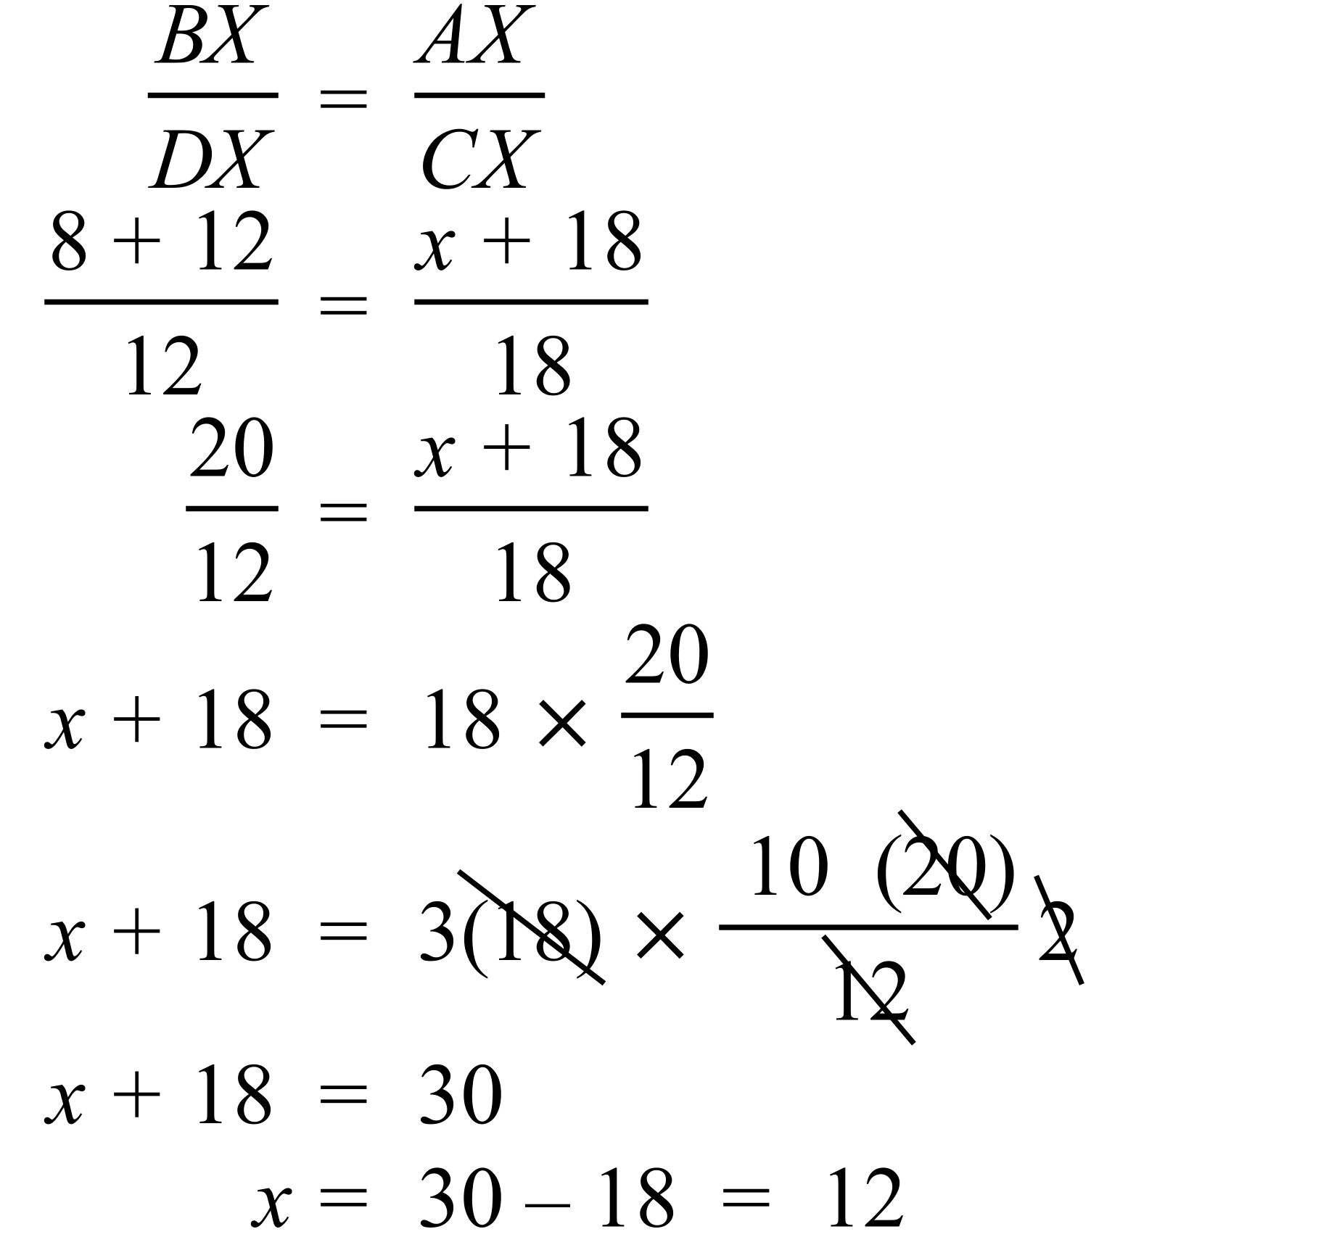 |  | x = 12

Year 10 |  | WME Solutions  Advanced Mathematics  Yearly | Calculator Allowed
Section 2 Part A Multiple Choice Section
ANSWERS
No. | WORKING |  |  | ANSWER
 | 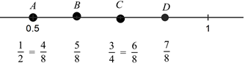 |  |  | B
 | 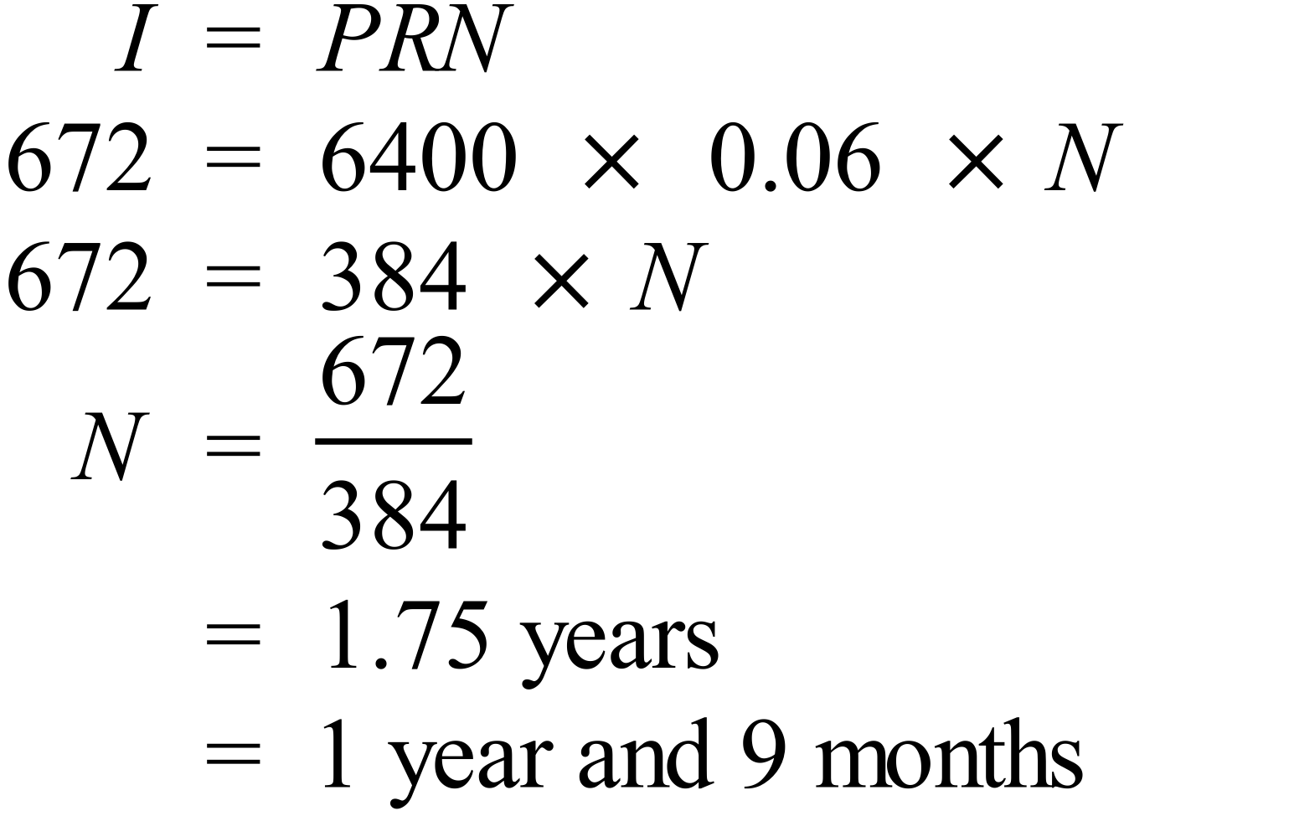 |  |  | B
 | 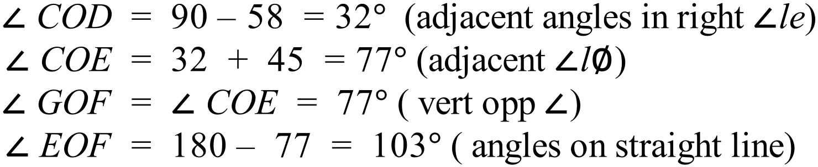  OTHER POSSIBLE REASONING |  |  | A
 | 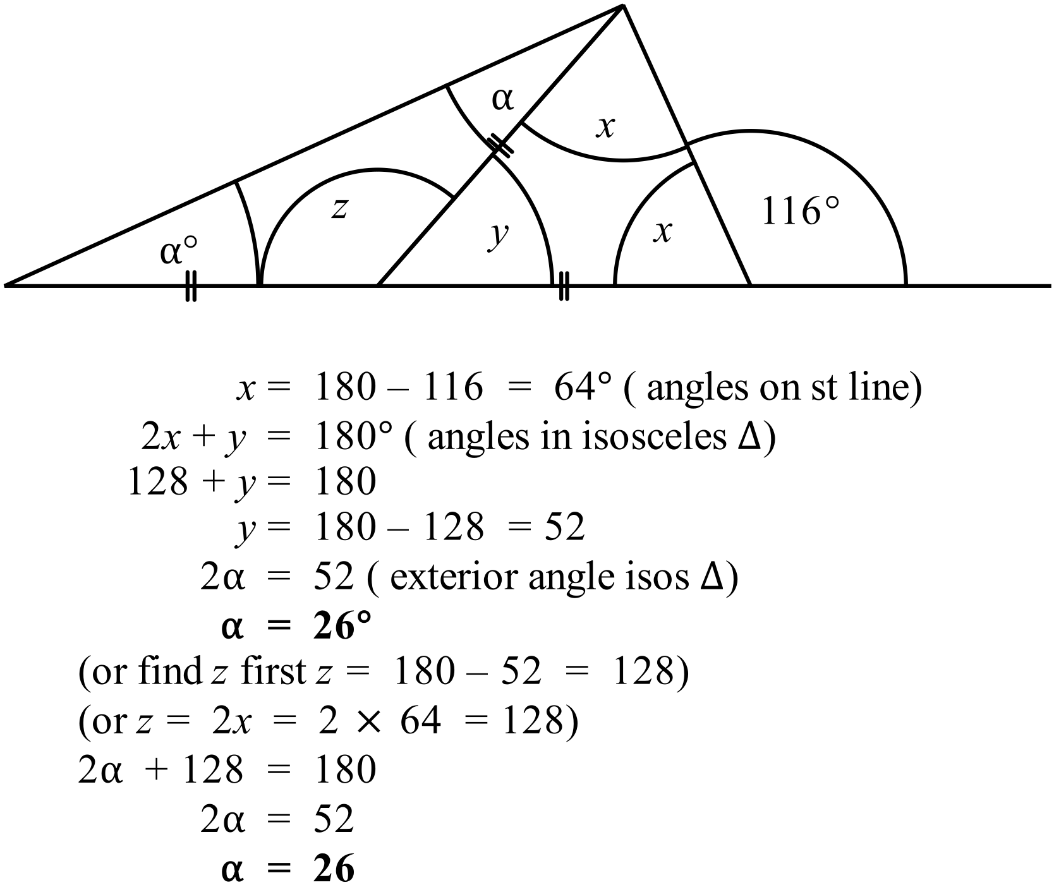 |  |  | B
 | 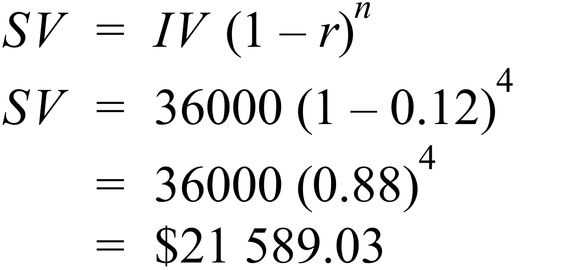 |  |  | B
 |  |  |  | D
 | 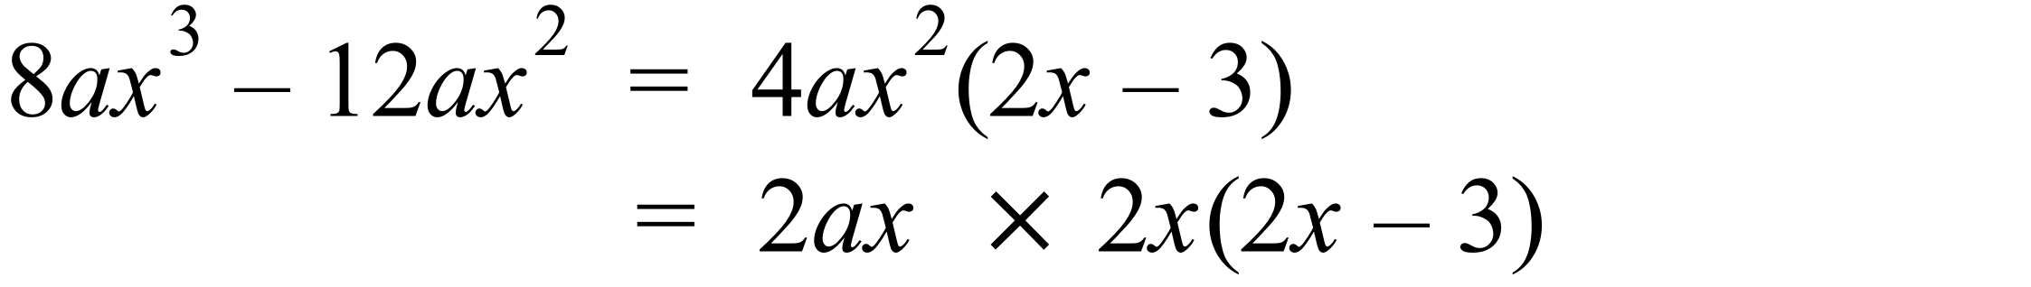 |  |  | A
 | 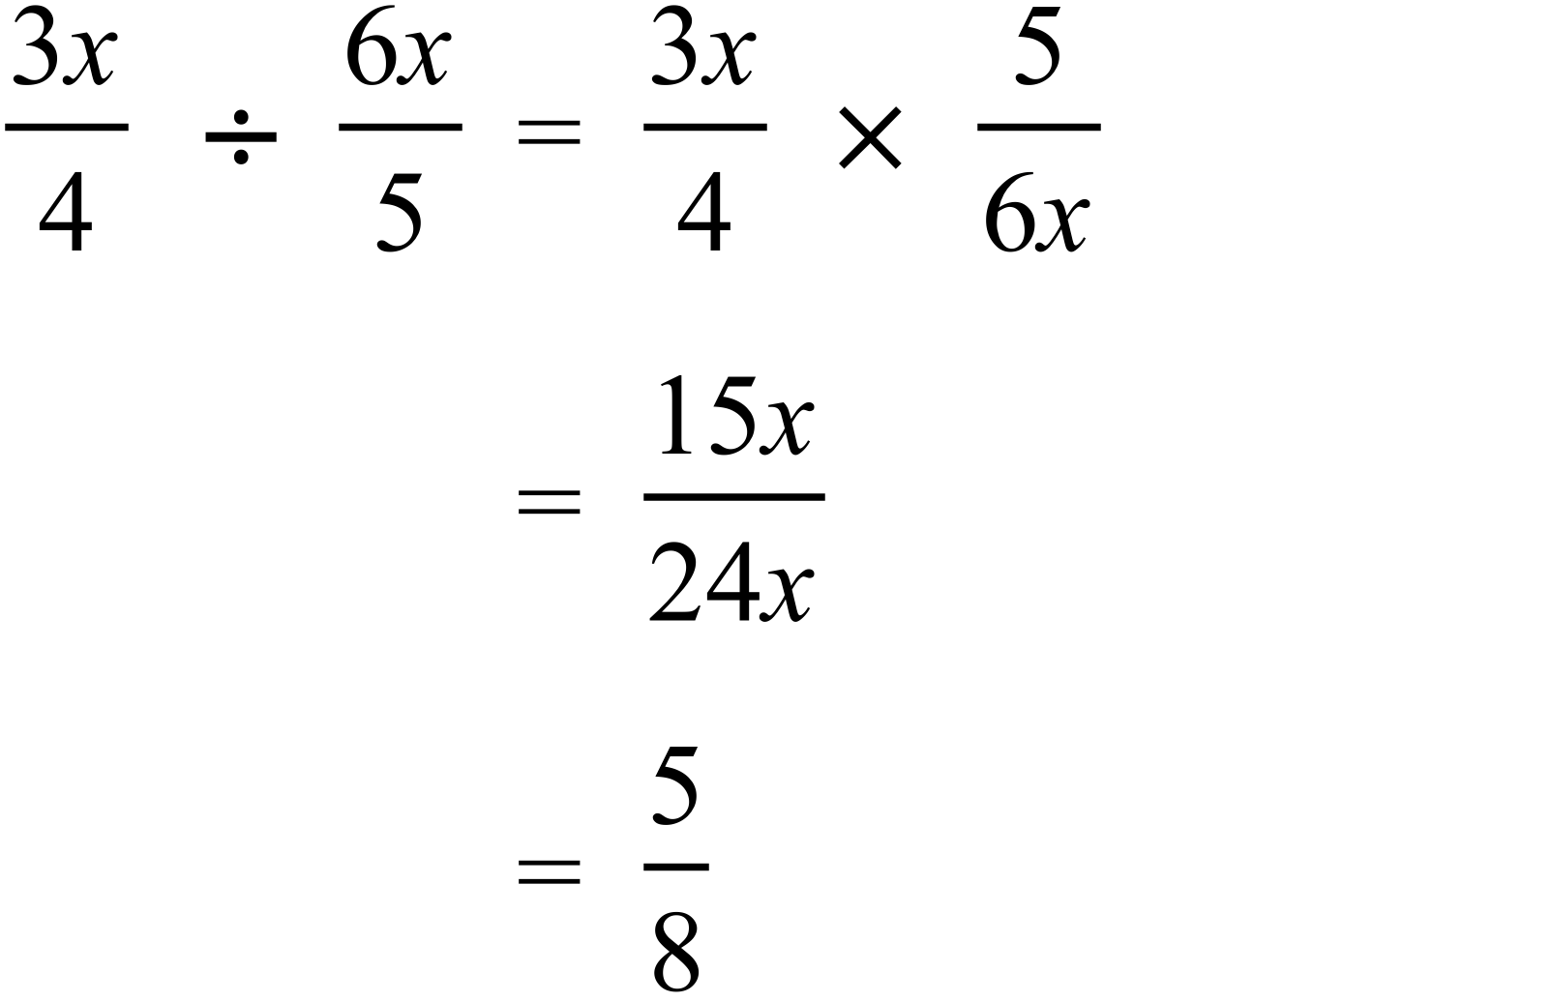 |  |  | A
 | 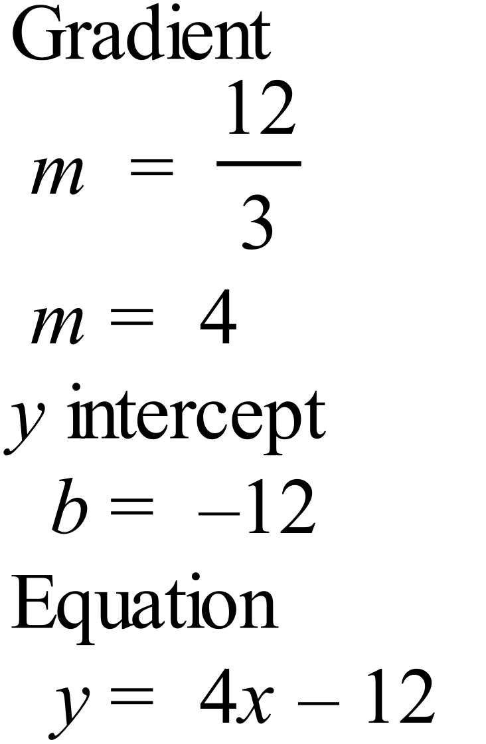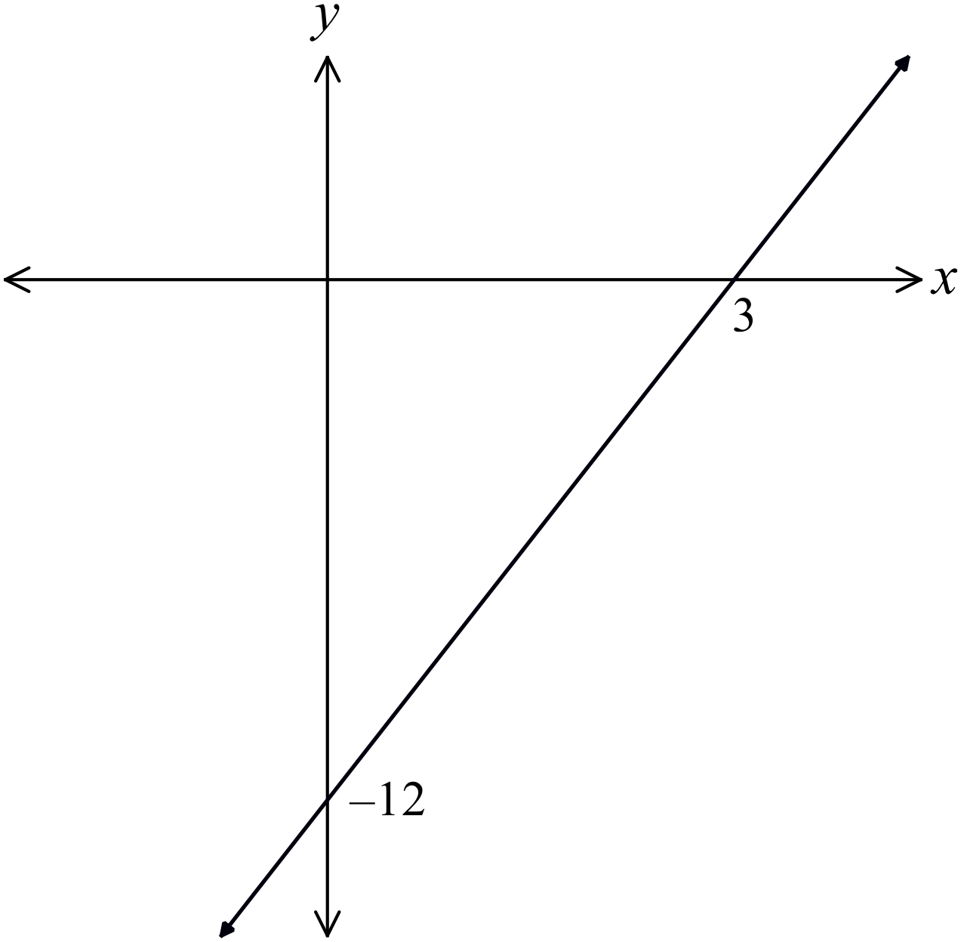 |  |  | D
 | 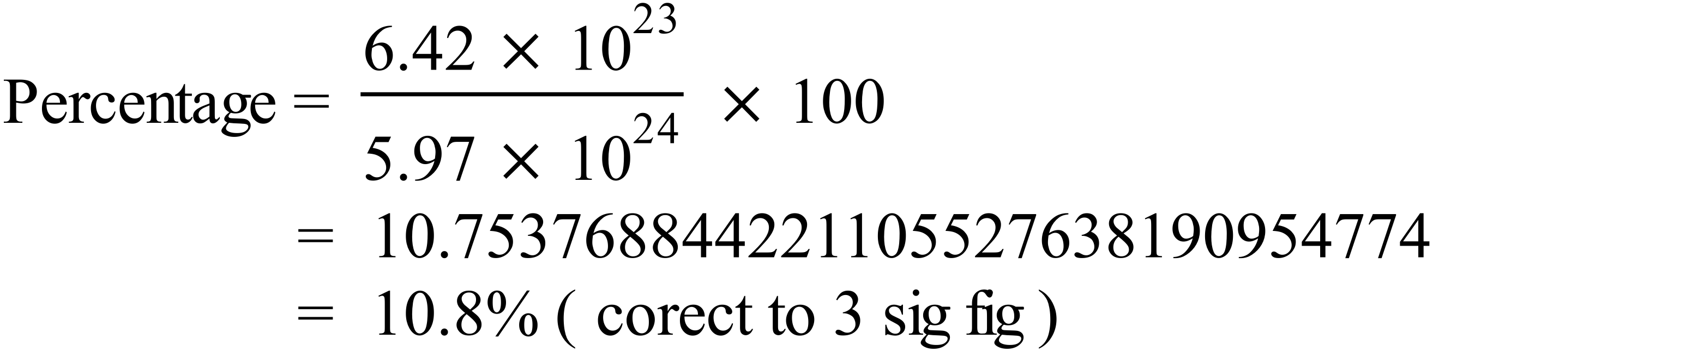 |  |  | A
 | 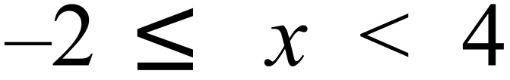  -2 is included, so is shaded and 4 is not so is not shaded, and x lies between these two, so the line joins -2 and 4. |  |  | B
 | 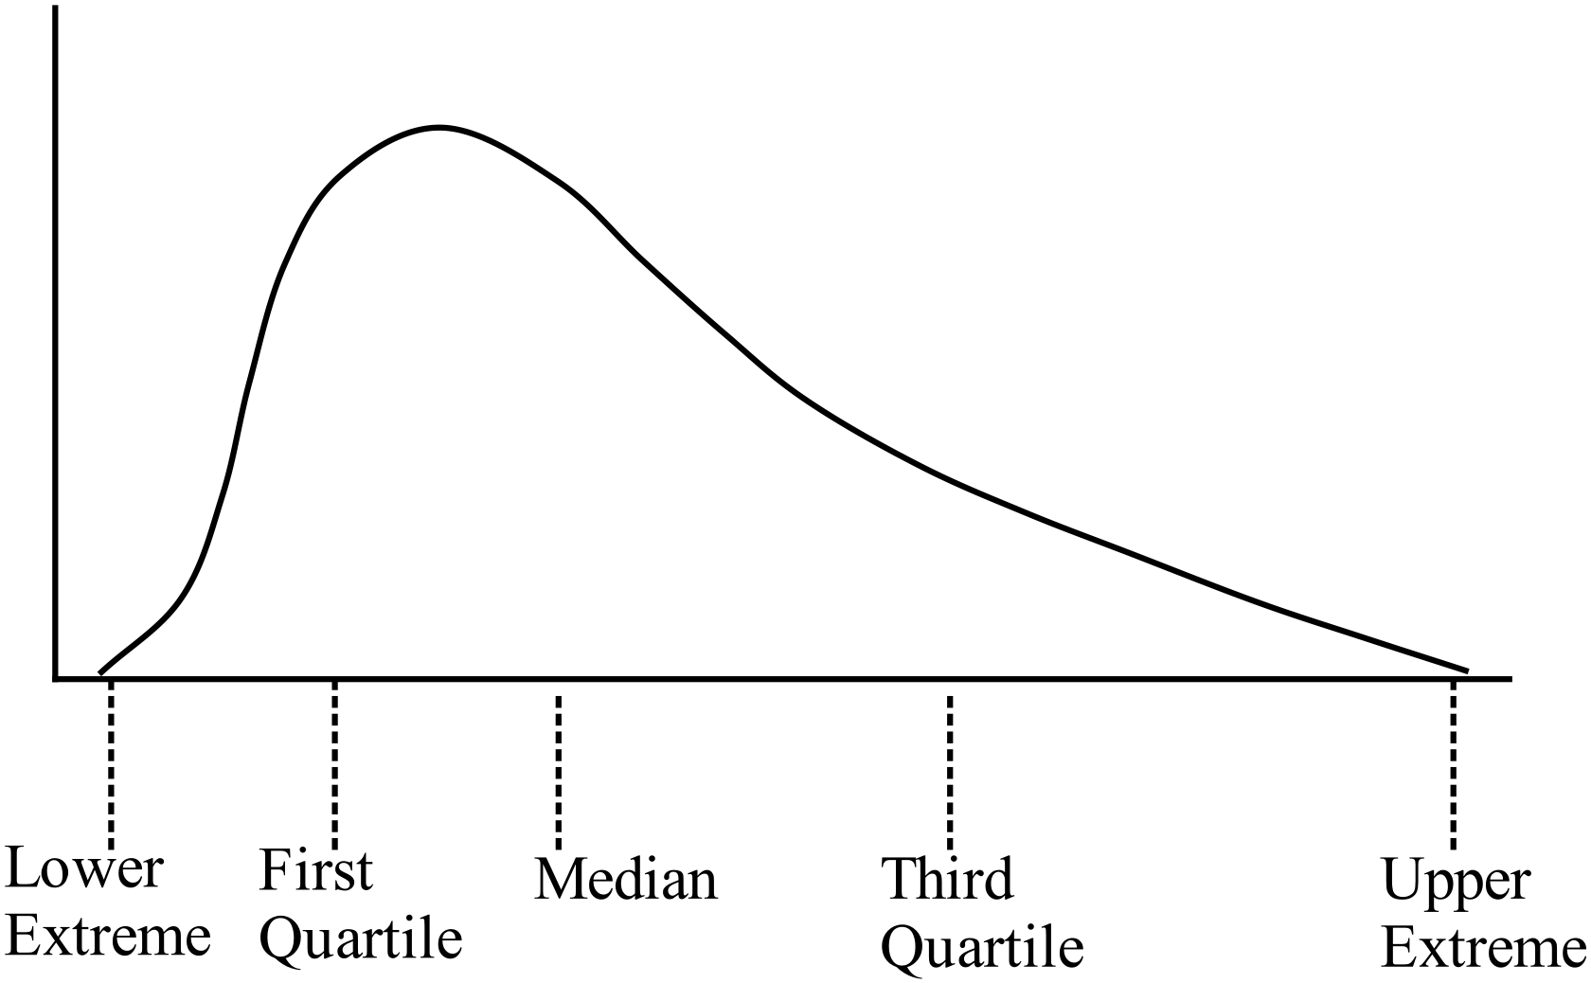As the lower quartile, lower extreme and median are more closely groups than the upper quartile and upper extreme, the scores are more bunched toward the lower values, so the tail is toward the top, so it is positively skewed. |  |  | C
 | 67 is the first quartile, so three-quarters of the scores will be equal or higher.  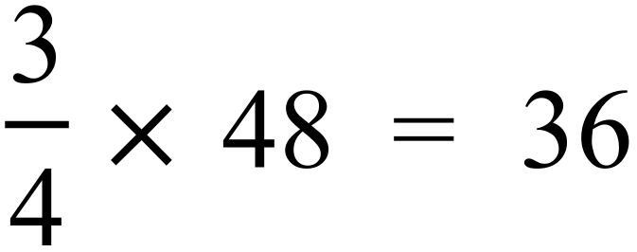 |  |  | D
 | 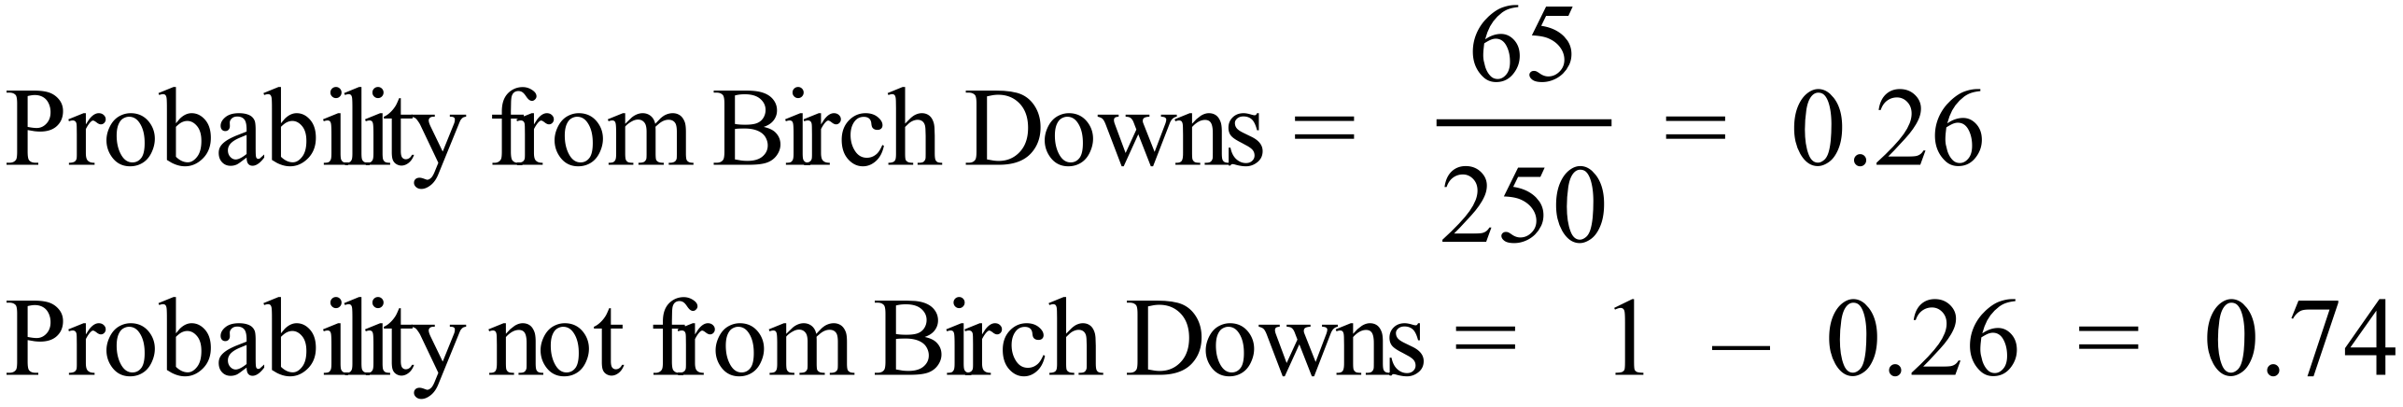 |  |  | C
 | Bearing of Daedalus = 270º – 34º = 236º |  |  | D
 | 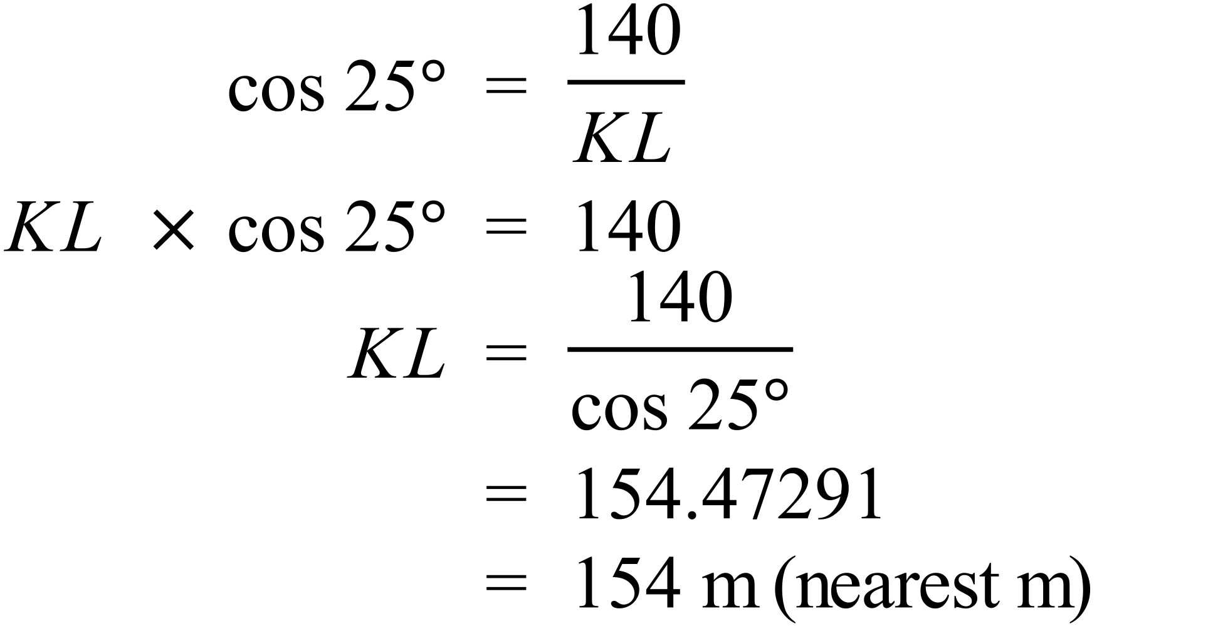 |  |  | A
 | 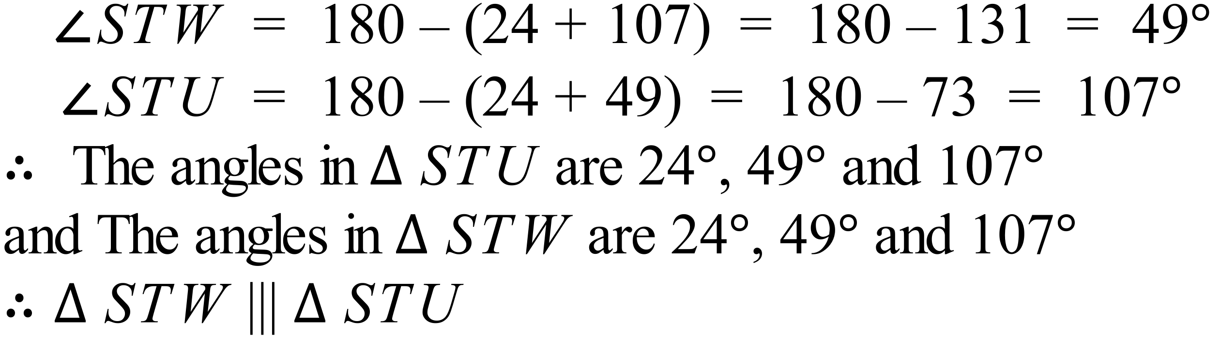 |  |  | A
 | 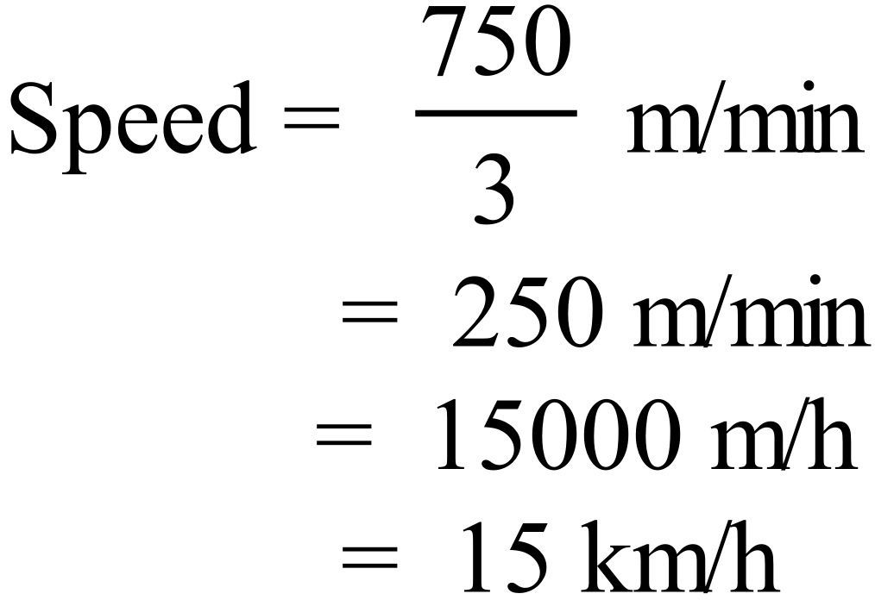 |  |  | D
 | Interest rate = 7.2% pa = 0.6% per month  Period = 4 years = 48 months  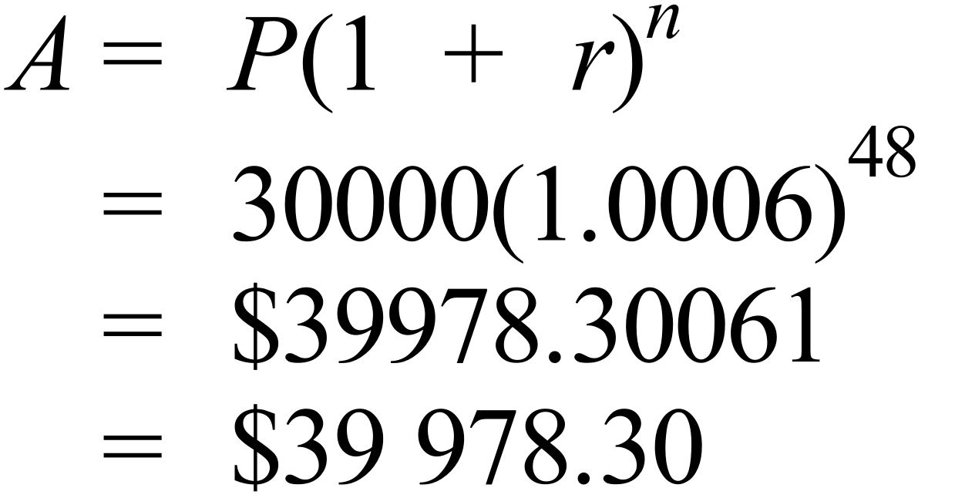 |  |  | C
 | 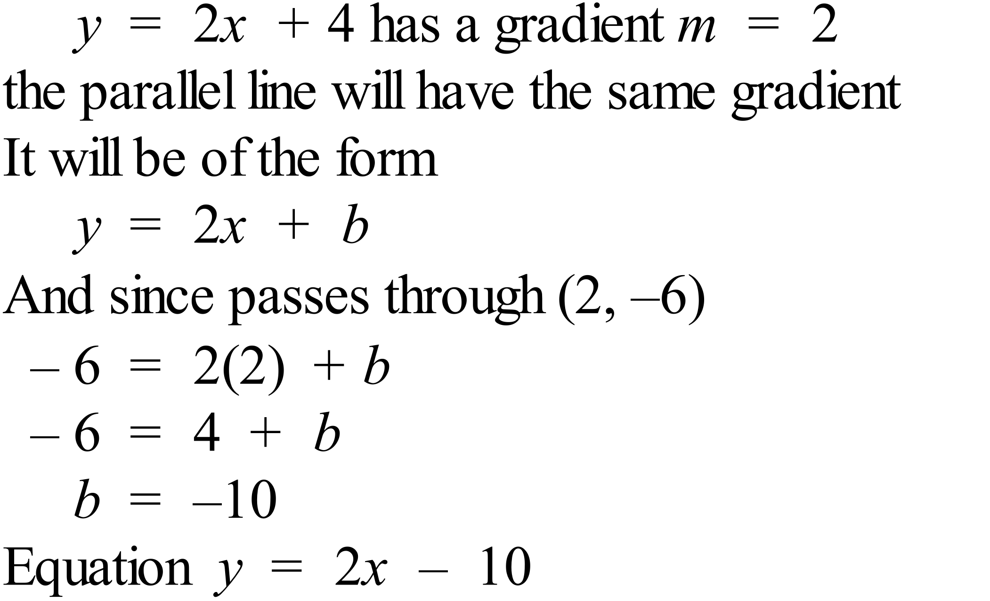 |  |  | C
 | 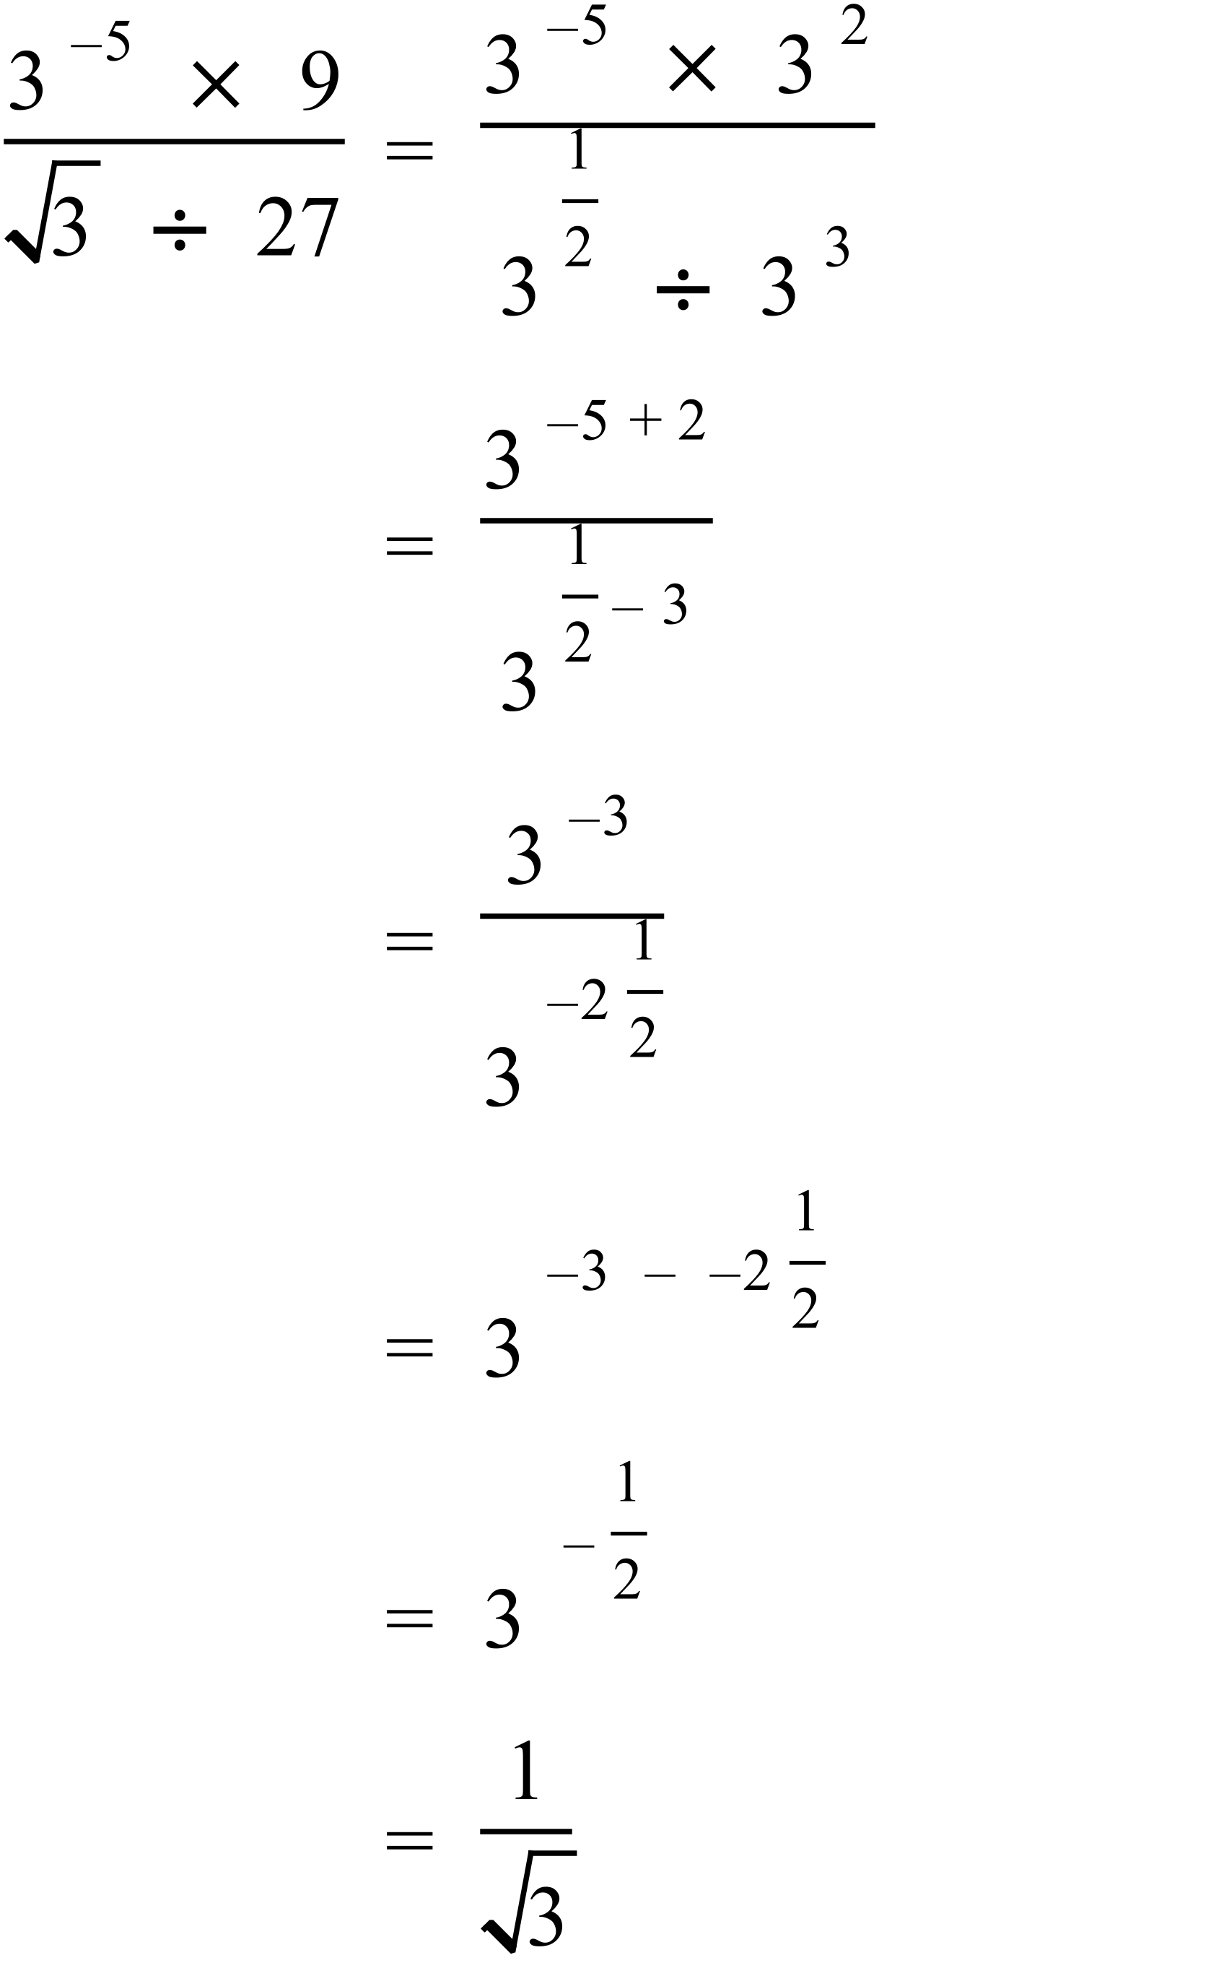 |  |  | B
 | 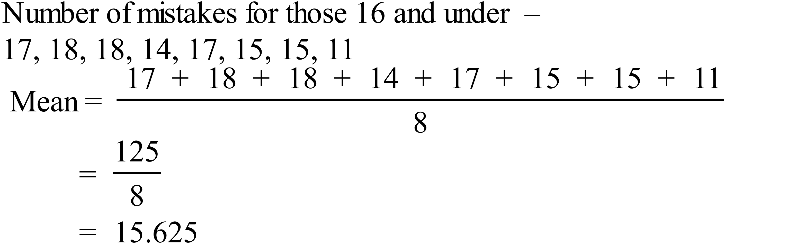 |  |  | D
 | The dots on the graph quite clearly follow a linear shape (straight line) so it is a strong relationship, and the number of mistakes decreases as the age increases so the relationship is negative.  So there is a strong negative relationship between age and number mistakes. |  |  | A
 | The graph has a y intercept of about 11, so only B and D have this.  The graph is exponential so equation is B 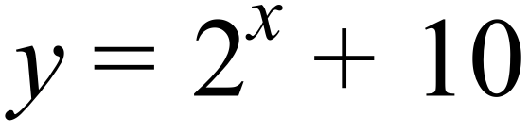  Or by testing a second point  e.g. when x = 6  B. 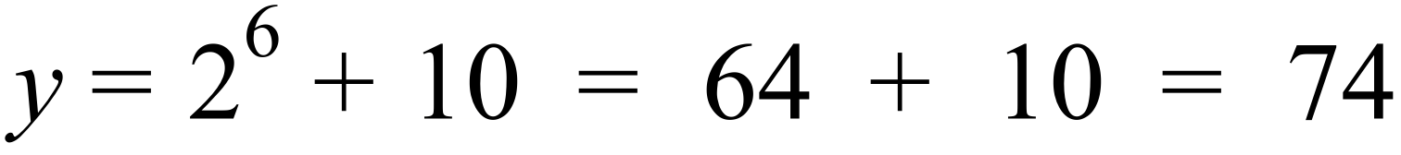  D. 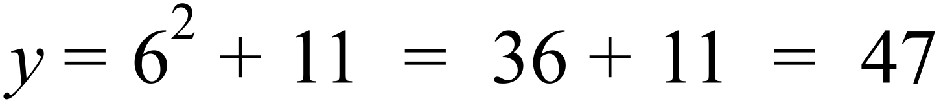  On Graph, when x = 6, y = 74 so correct graph is B. |  |  | B
 | 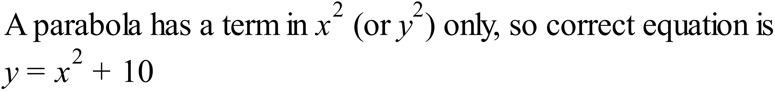 |  |  | C
 | 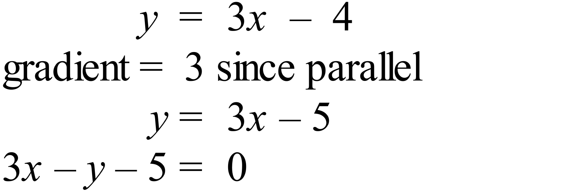 |  |  | C
 | 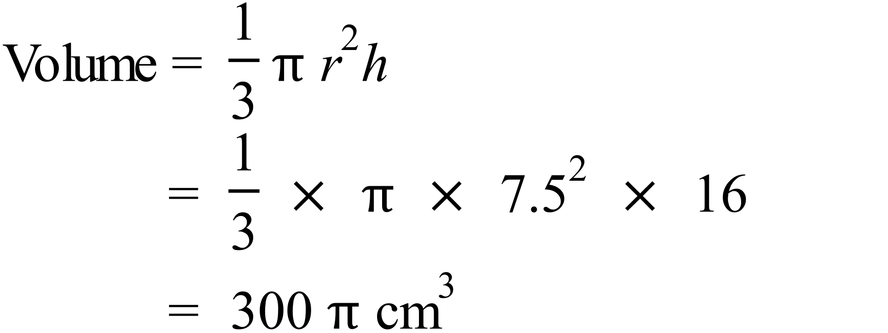 |  |  | A
 | 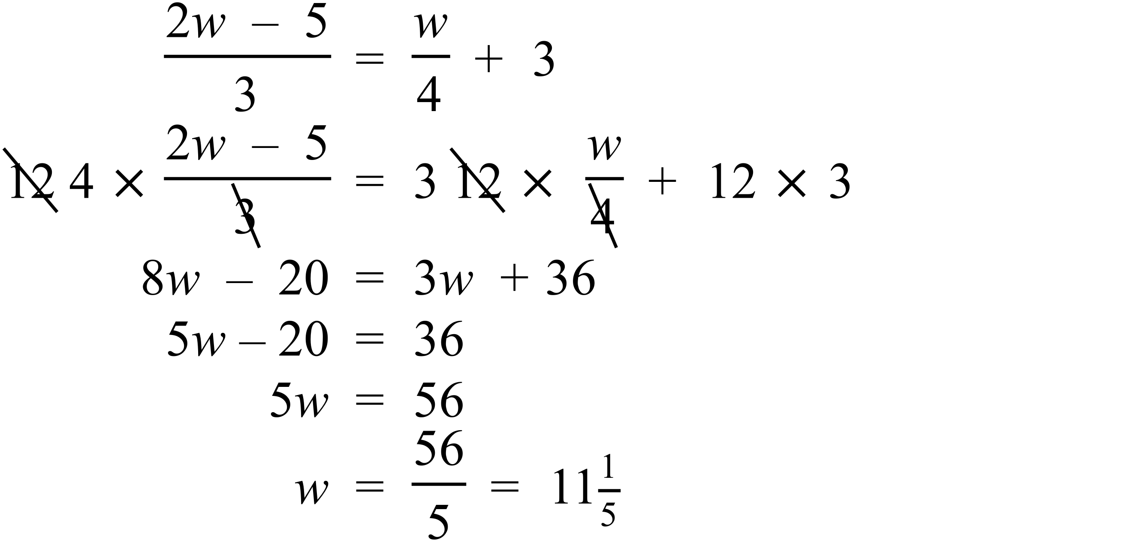 |  |  | D
 | 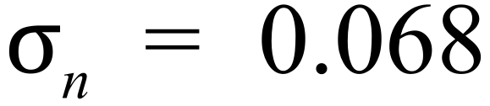 from calculator |  |  | A
 | 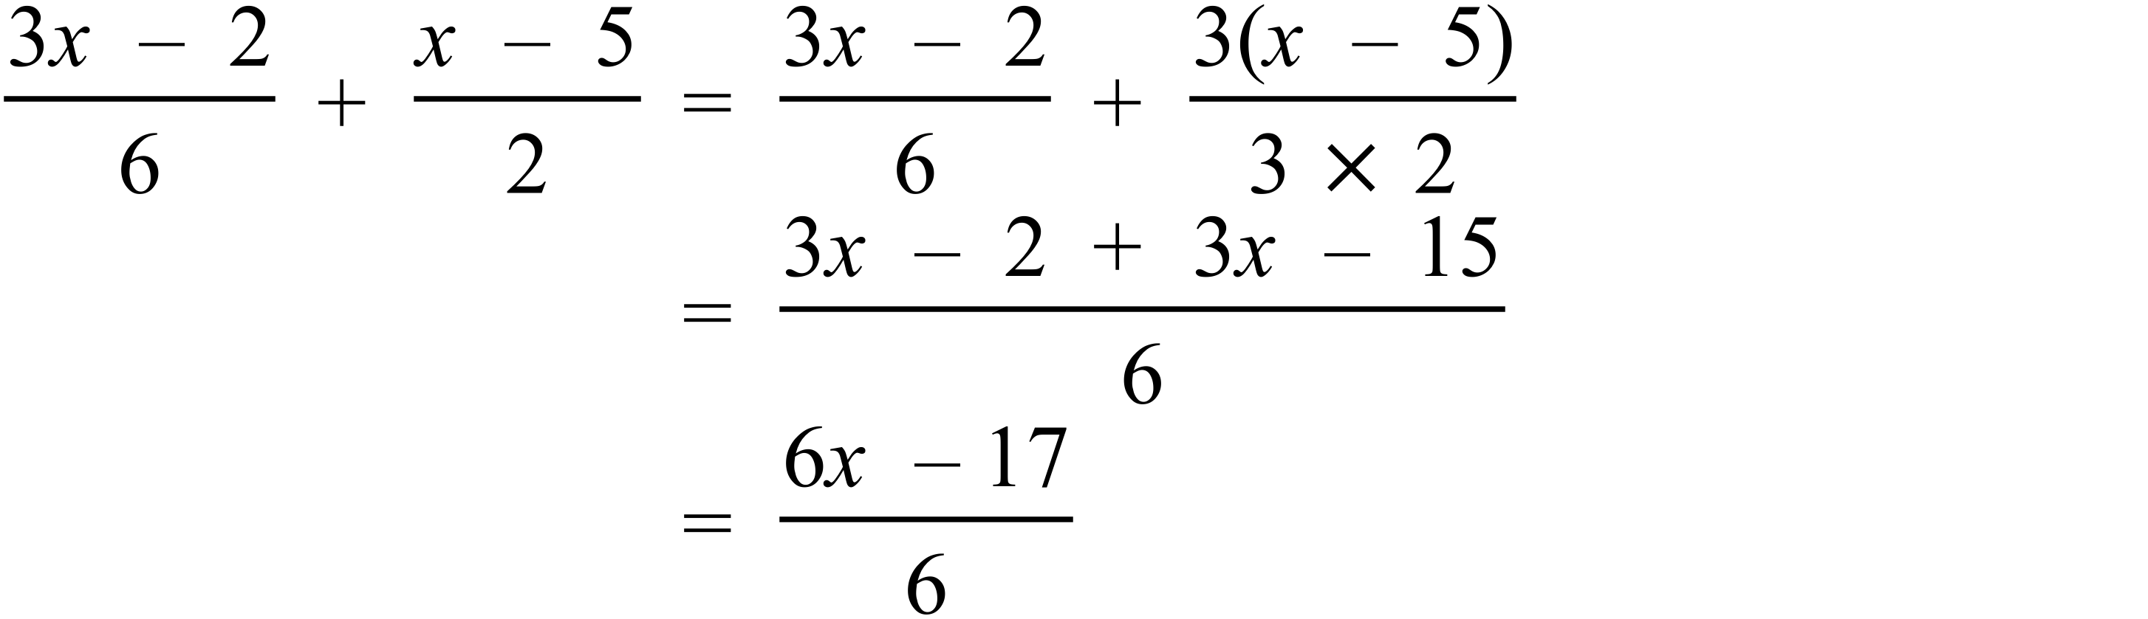 |  |  | C
 | The curve is a hyperbola with asymptote at 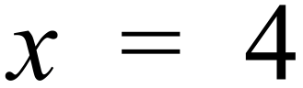  So equation is of the form 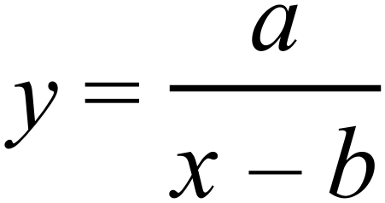 where b is the x value of the asymptote.  So possible equation is 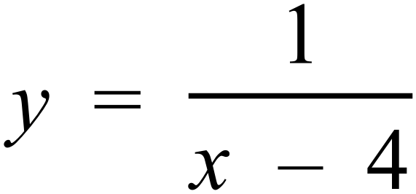 |  |  | C
 | 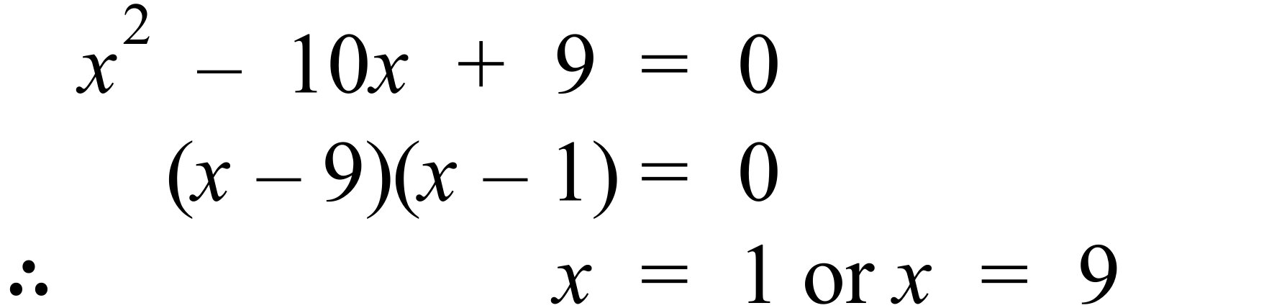 |  |  | D
 | To make y the subject of equation (2) would be a step in using the substitution method, but it gives a rather complicated equation 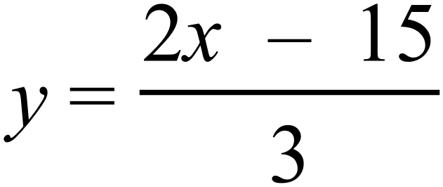 to substitute into equation (1). |  |  | B
 | Starts from a stationary position, so the graph needs to start at zero, and since the acceleration changes, it needs to be a curved line. The acceleration increases to begin with, so the curve gets steeper, then decreases back to zero, so the slope decreases till it is horizontal. This describes graph A. |  |  | A
 | 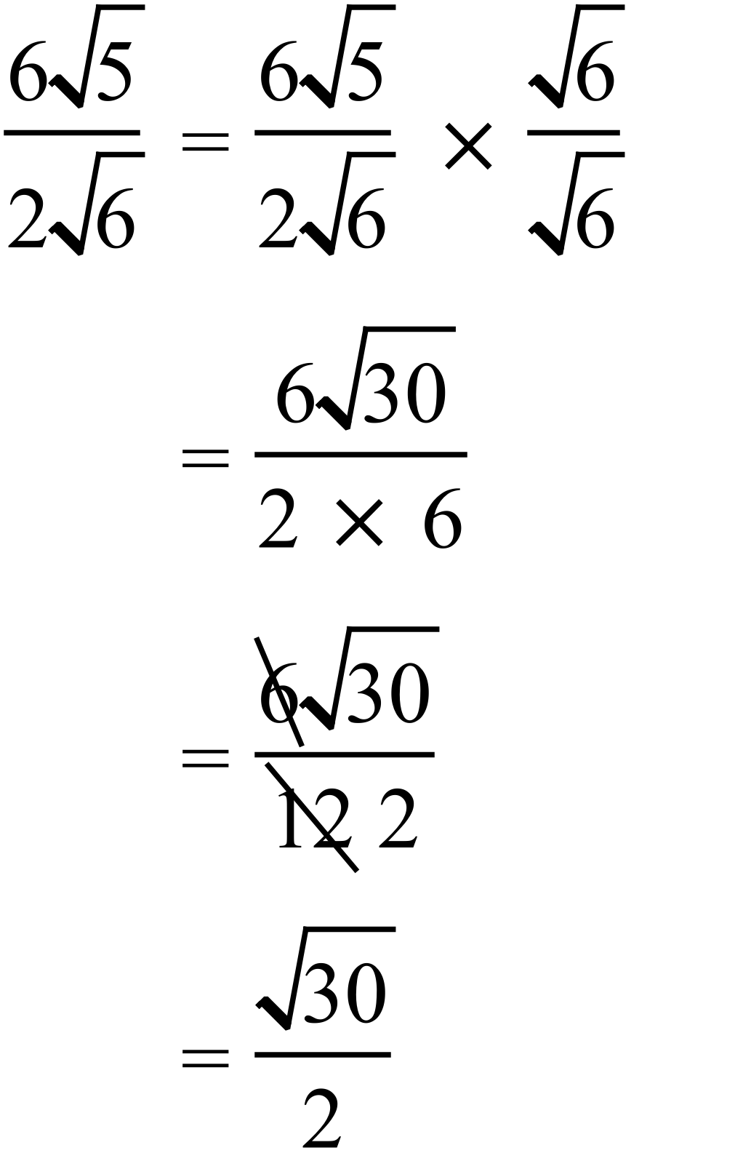 |  |  | C
 | Circumference = 70 cm 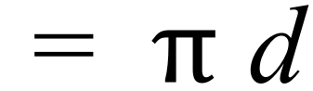  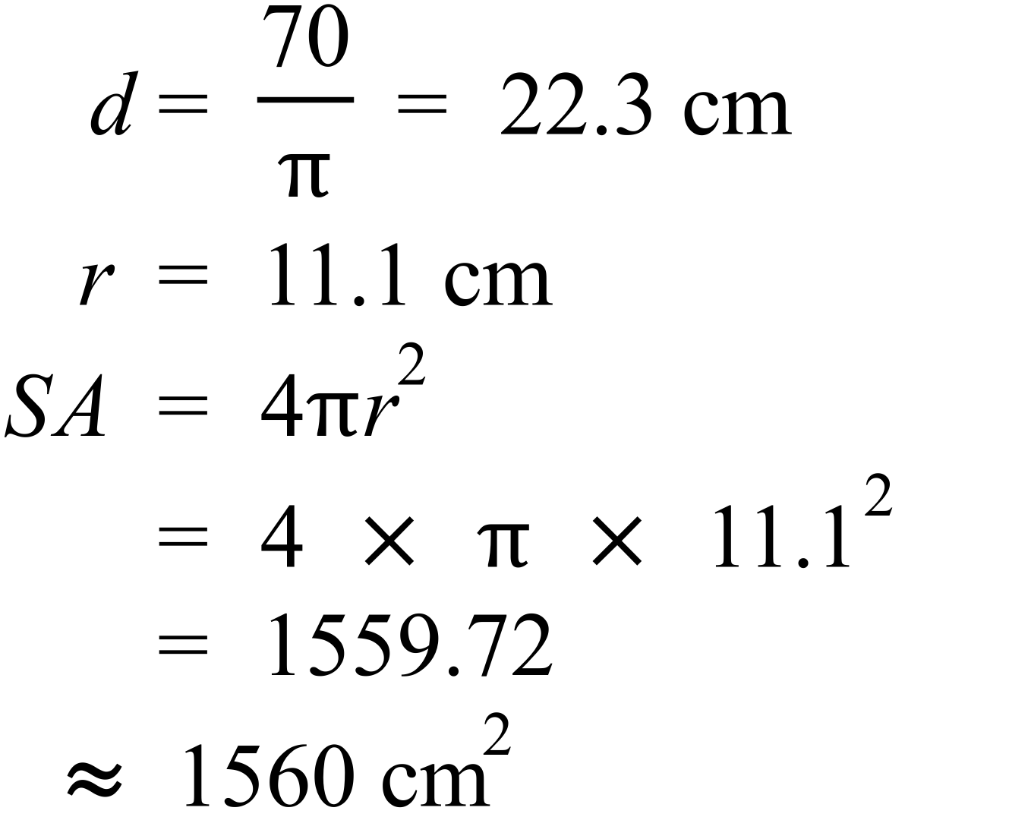 |  |  | A
 | 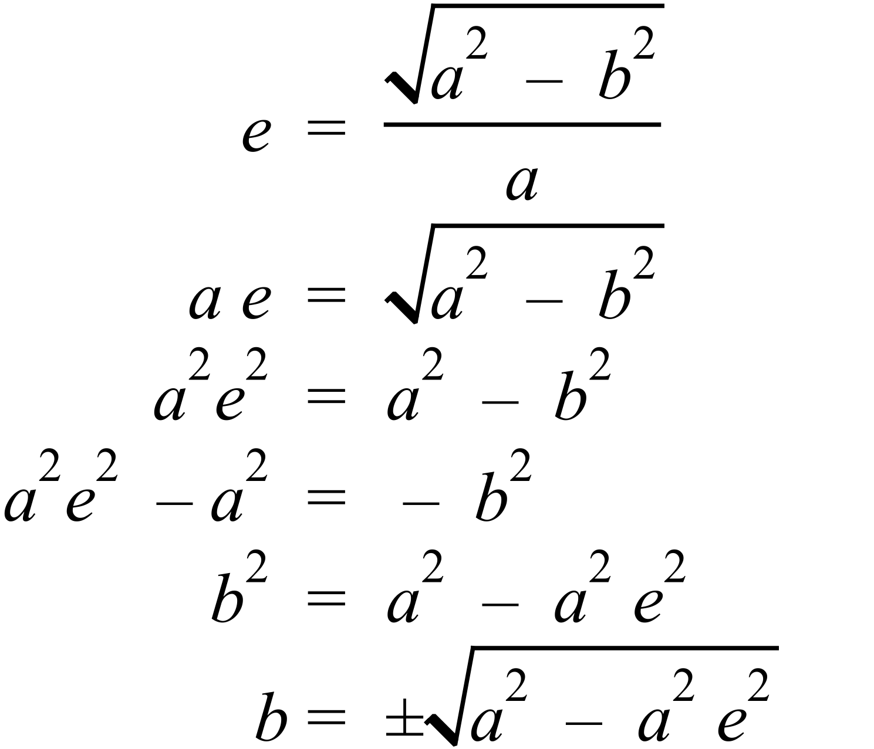 |  |  | B
 |  |  |  | D
 | 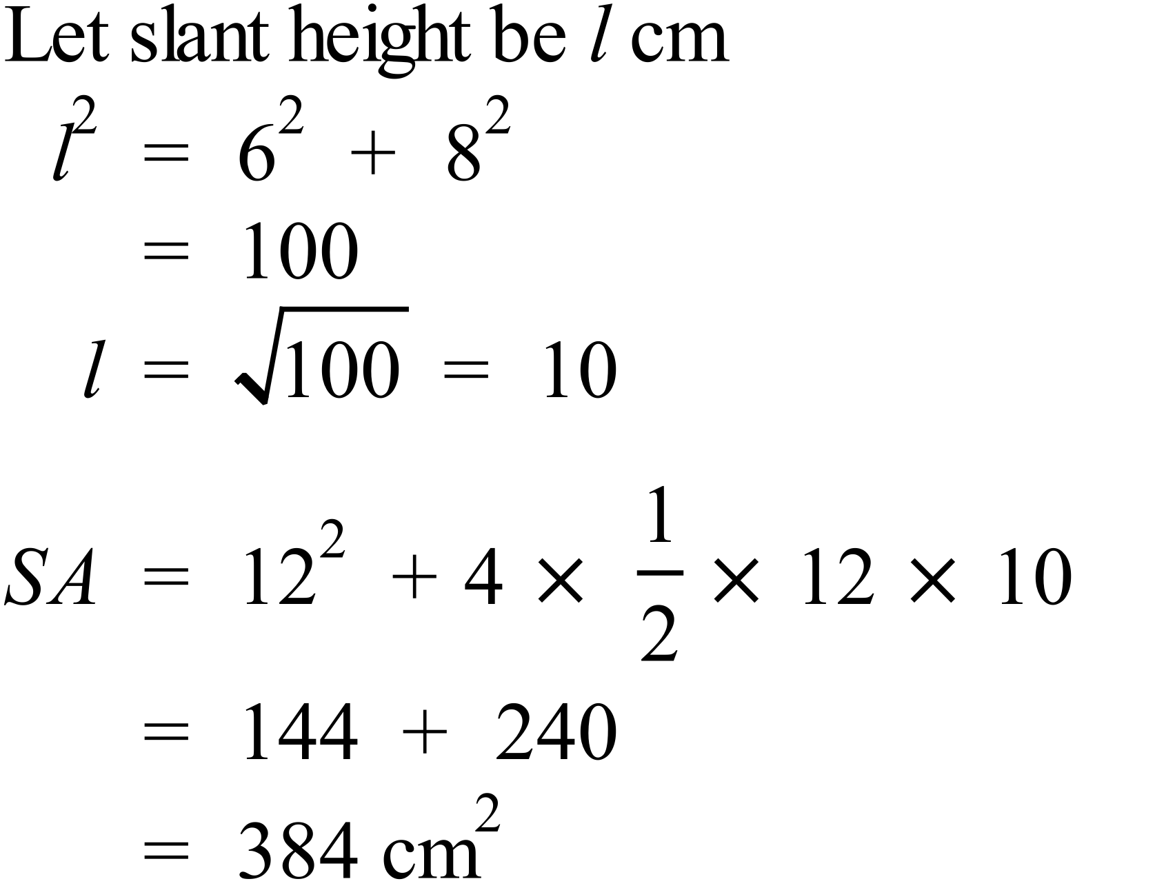 |  |  | D
 | Morning flights have the greater mean, so it they are longer on average, so A and C are incorrect.  Afternoon flights have the greater standard deviation, so they have more variation, so B is incorrect and D is correct.. |  |  | D
 | 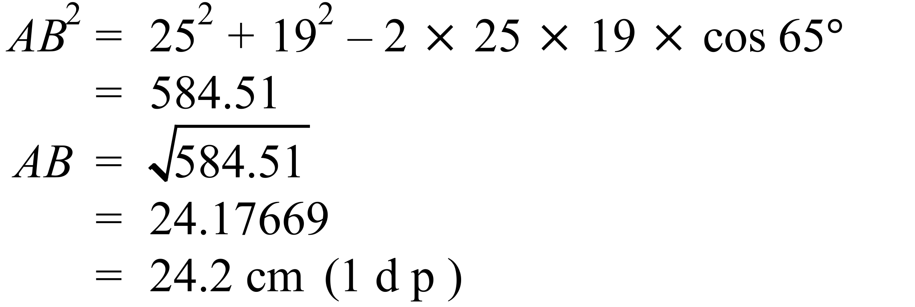 |  |  | B
 | 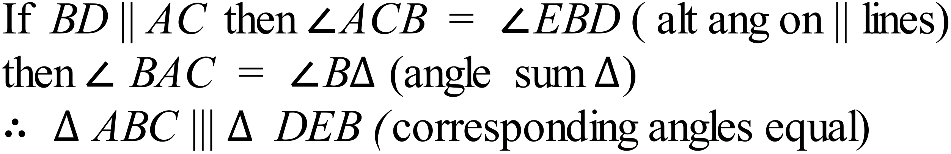 |  |  | D
 | 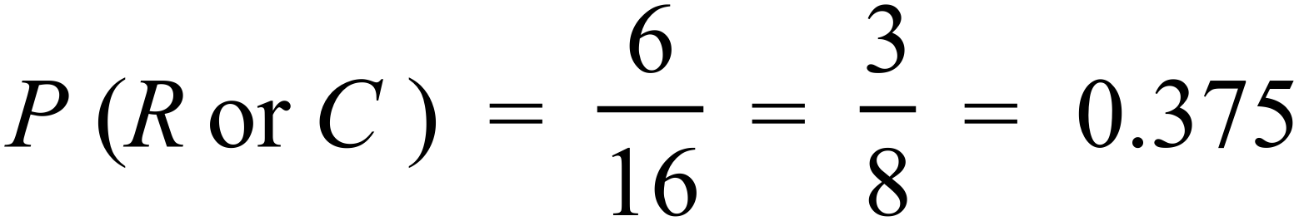 |  |  | C
  Colour | Style | Sedan | Hatch | Ute | Coupe
  Red |  | RS | RH | RU | RC
  Blue |  | BS | BH | BU | BC
  White |  | WS | WH | WU | WC
  Green |  | GS | GH | GU | GC
 | Find the gradient of line through (2, –1) and (–2, 7)  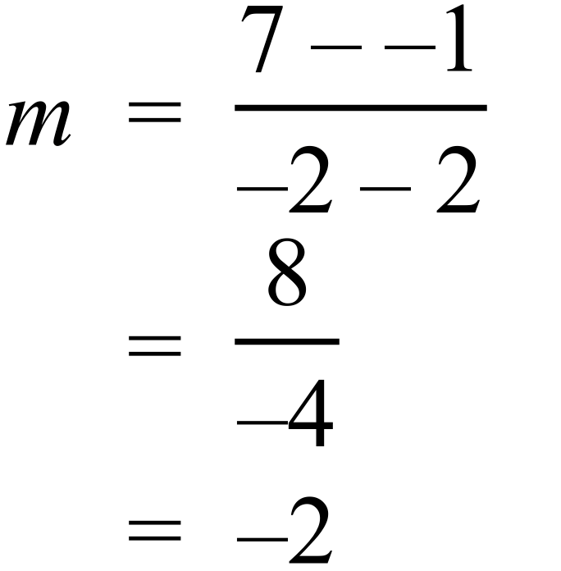  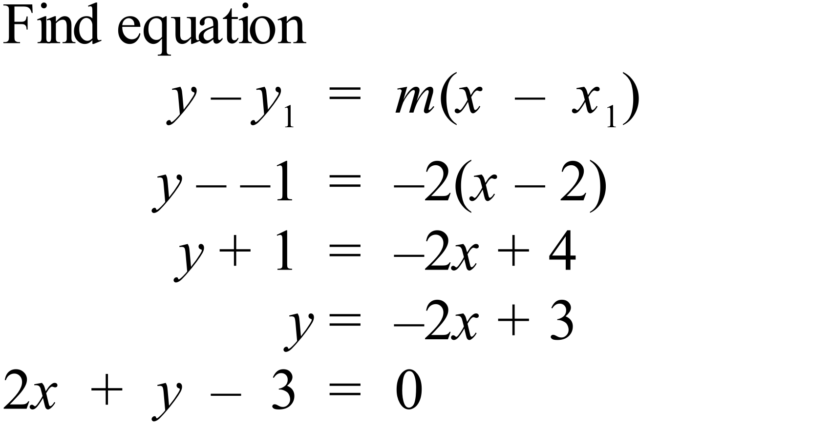 |  |  | C
 | 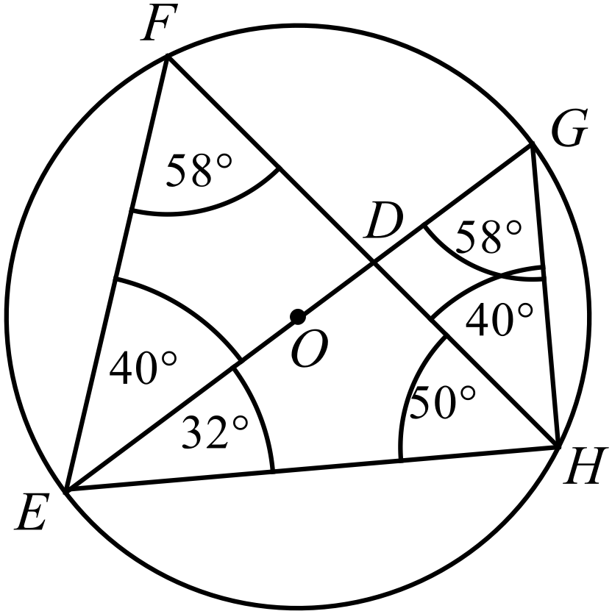  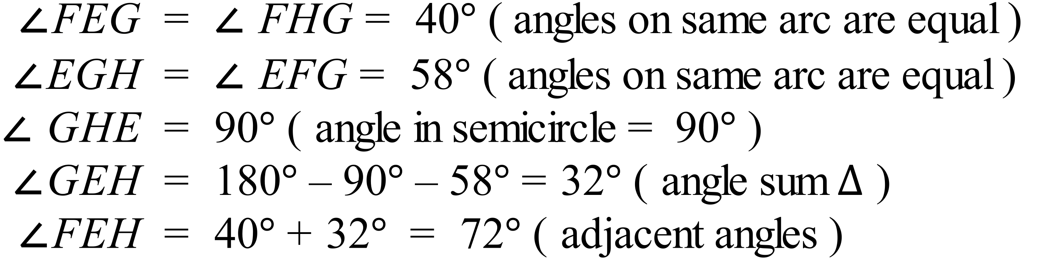 |  |  | B
 | 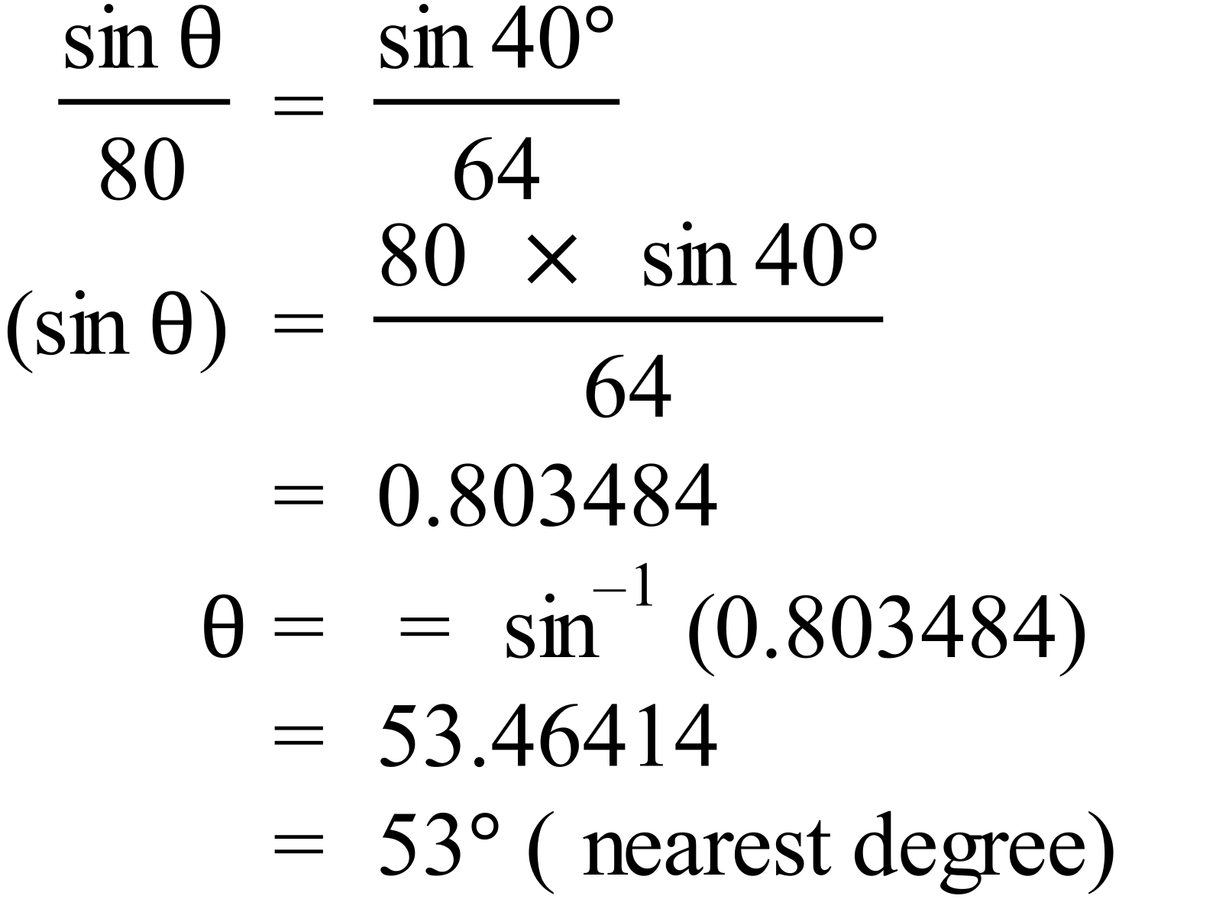 |  |  | D
 | 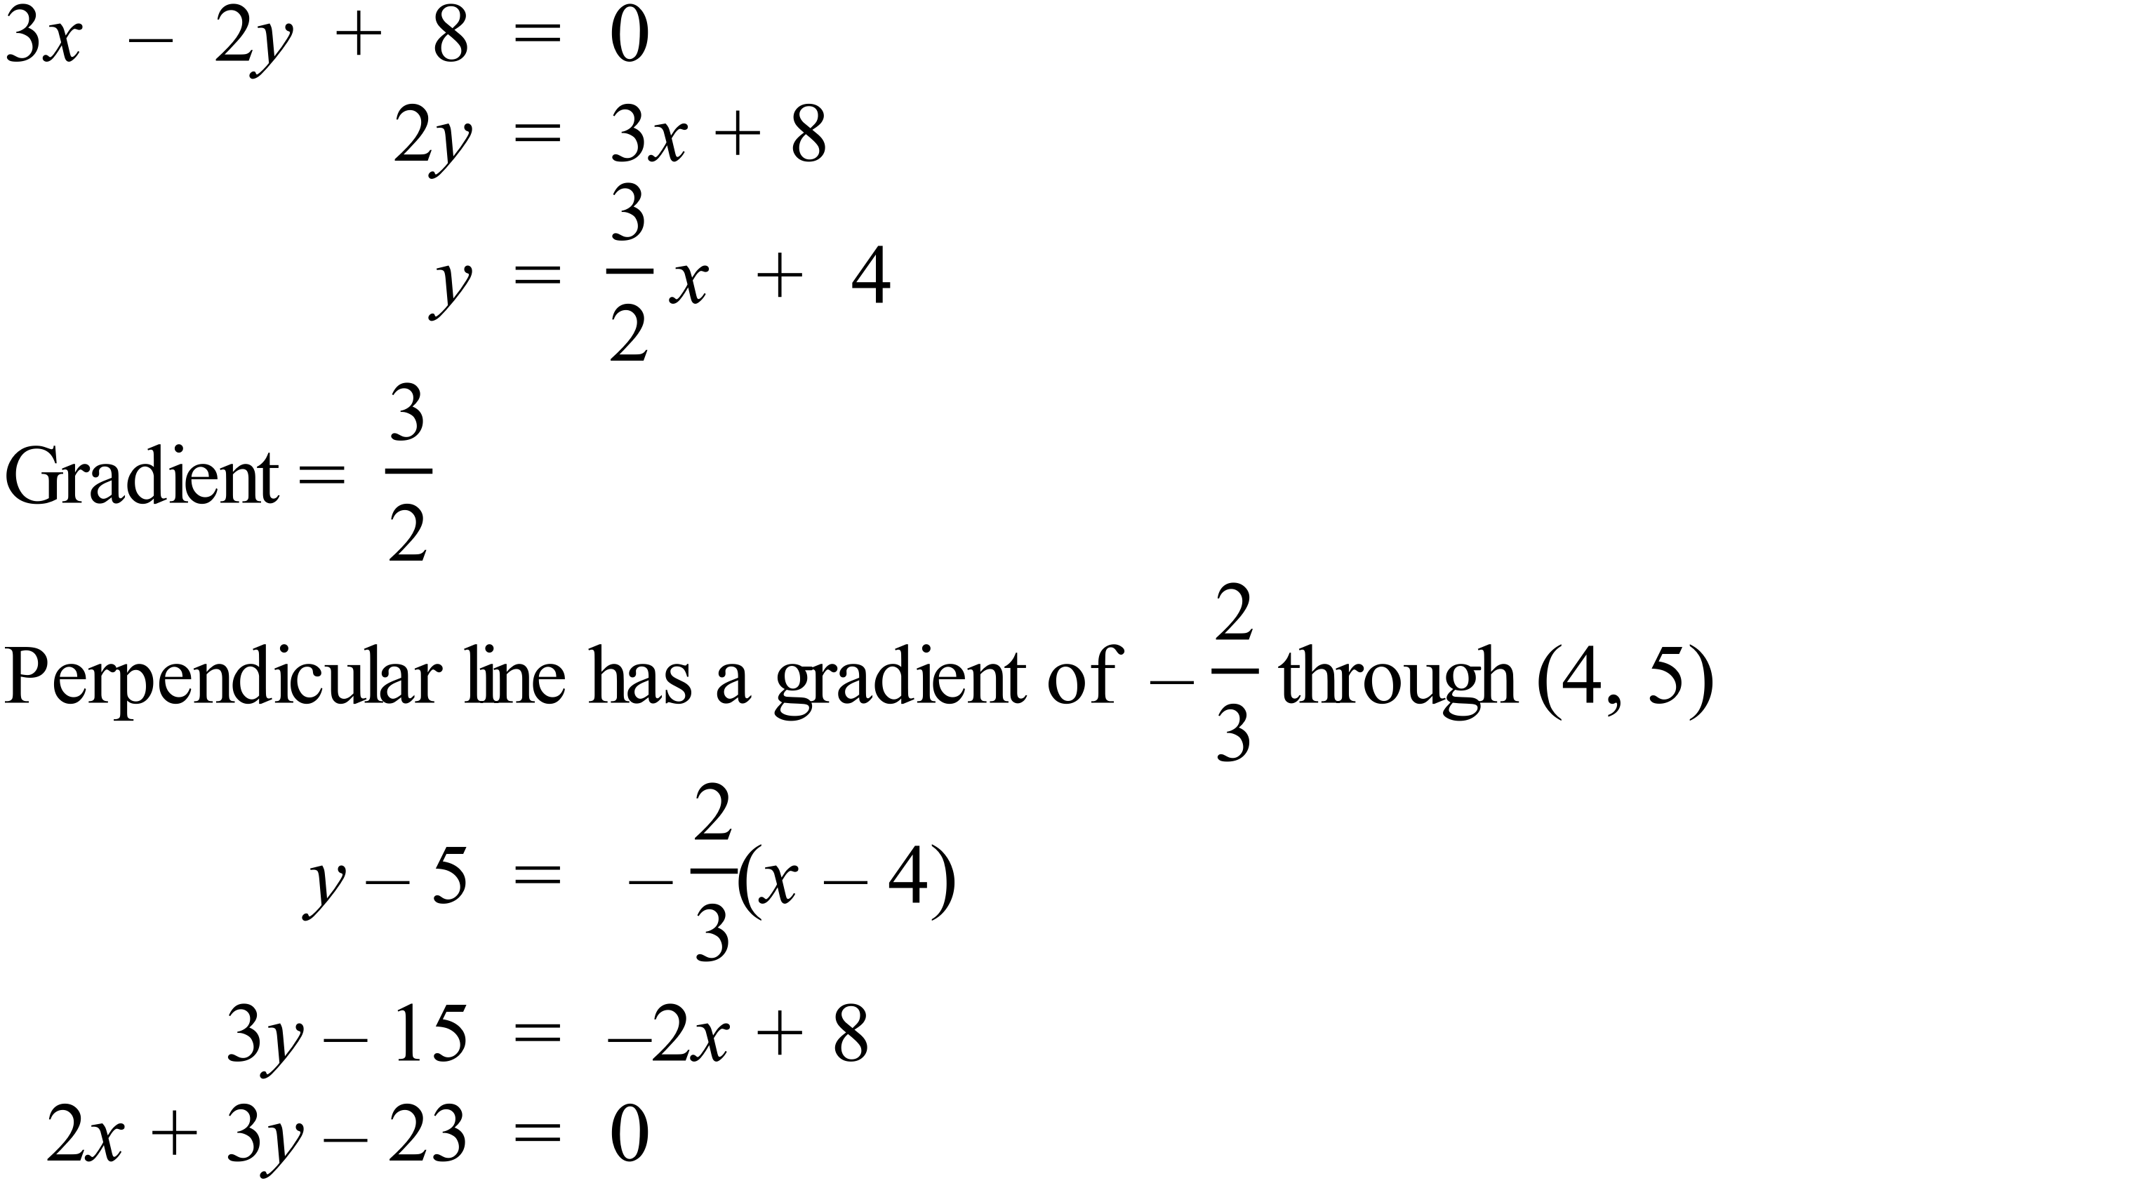 |  |  | B
 | 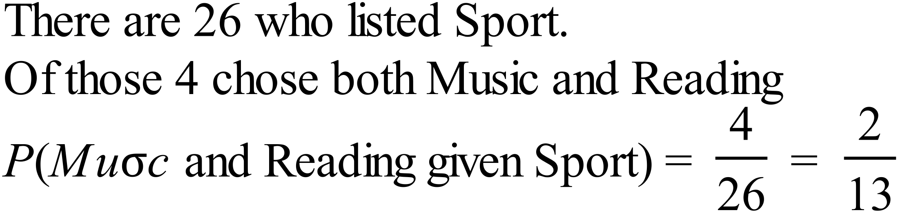 |  |  | A
 | 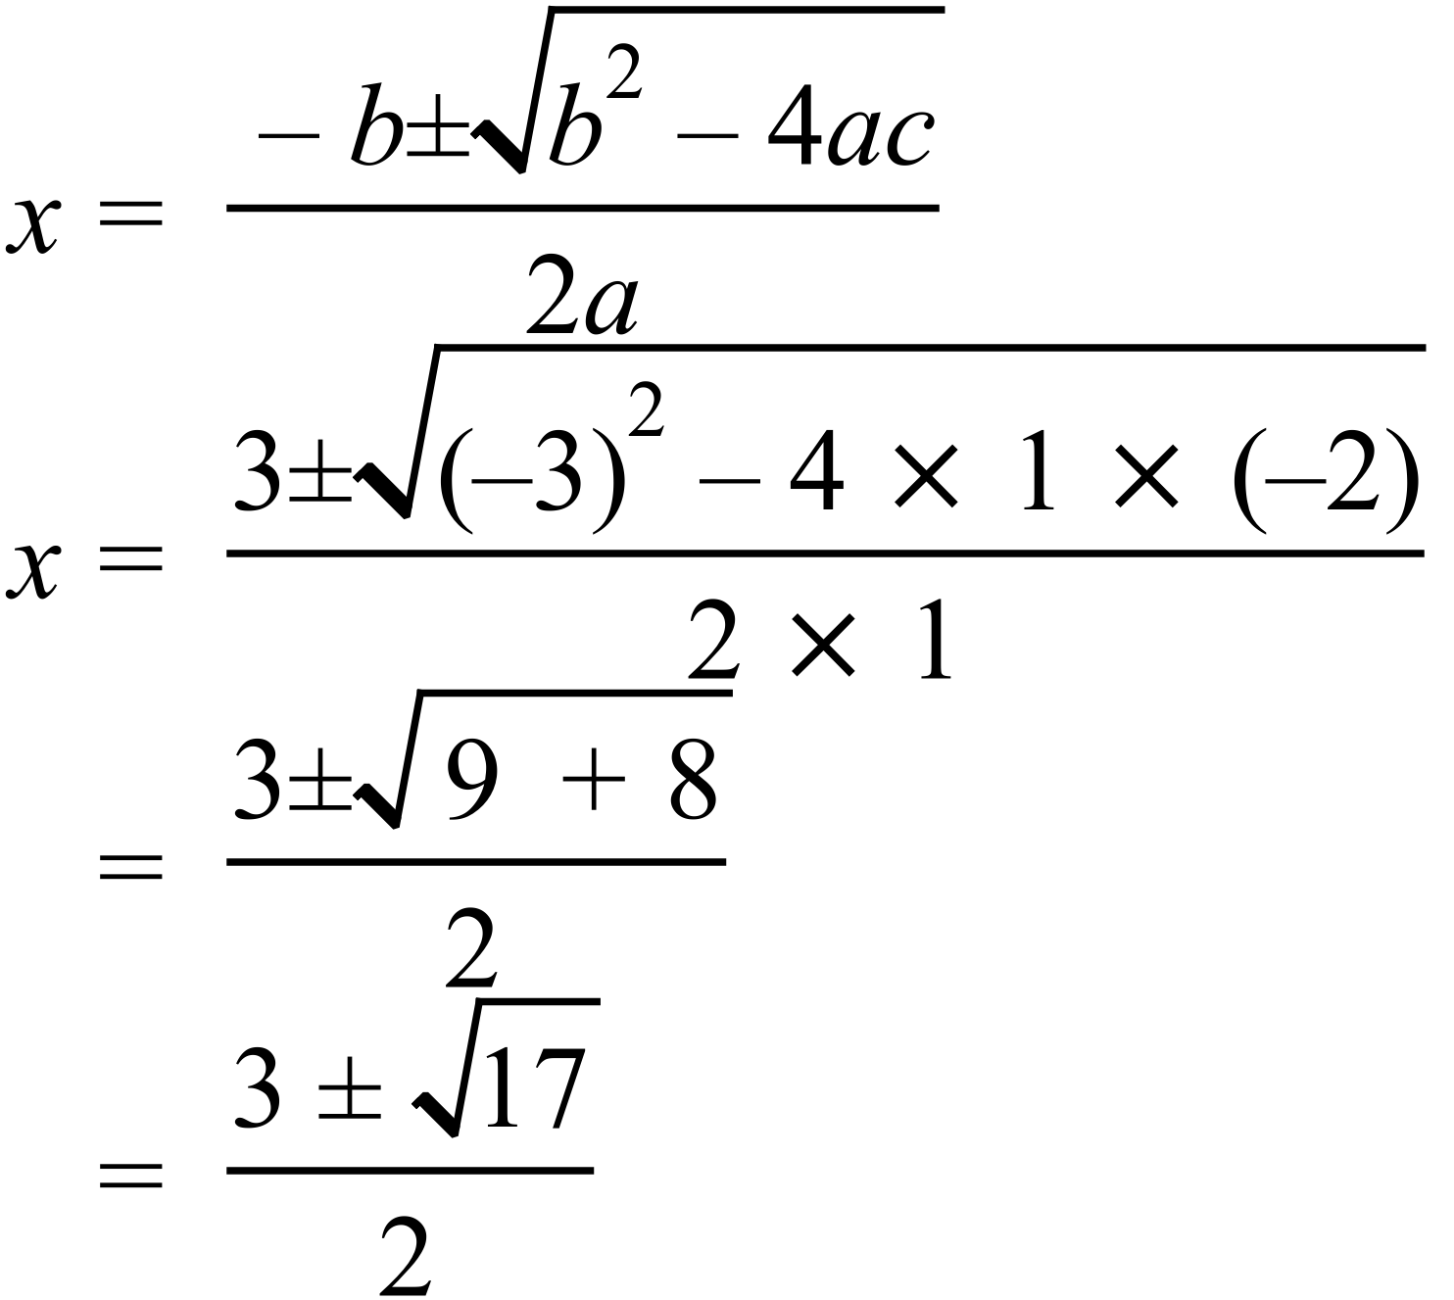 |  |  | D
 | 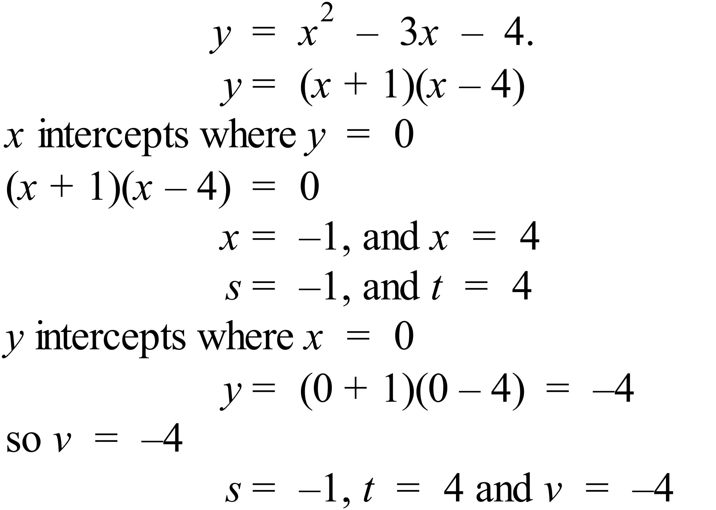 |  |  | B

School Name
Year 10 Advanced Mathematics Examination
Solutions 2016
Multiple Choice Section Answer Sheet

Name _______Marking Sheet________ Teacher ________________________

Completely fill the response oval representing the most correct answer.
Use a black or blue pen or 2B pencil.

26. A B C D
27. A B C D
28. A B C D
29. A B C D
30. A B C D
31. A B C D
32. A B C D
33. A B C D
34. A B C D
35. A B C D
36. A B C D
37. A B C D
38. A B C D
39. A B C D
40. A B C D
41. A B C D
42. A B C D
43. A B C D
44. A B C D
45. A B C D
46. A B C D
47. A B C D
48. A B C D
49. A B C D
50. A B C D

51. A B C D
52. A B C D
53. A B C D
54. A B C D
55. A B C D
56. A B C D
57. A B C D
58. A B C D
59. A B C D
60. A B C D
61. A B C D
62. A B C D
63. A B C D
64. A B C D
65. A B C D
66. A B C D
67. A B C D
68. A B C D
69. A B C D
70. A B C D
71. A B C D
72. A B C D
73. A B C D
74. A B C D
75. A B C D

Year 10 |  | WME Solutions  Advanced Mathematics  Yearly 2016 | Calculator Allowed
Section 2 Part B Longer Answer Section
ANSWERS
 |  |  |  | Marks
76. (a) |  |  |  | 2 marks for all correct measures.  1 mark for answer which has at least two correct measures
  Number (n) = | 26
  Mean ( 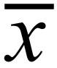 ) = | 5.04
  Median = | 5
  Standard deviation (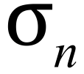) = | 1.43
(b) | Both Groups had around the same mean and median so the centre of the data was similar, but group B was considerably more spread from the centre. |  |  | 1 mark for any reasonable answer which includes mention of difference in the spread.
77. (a) | 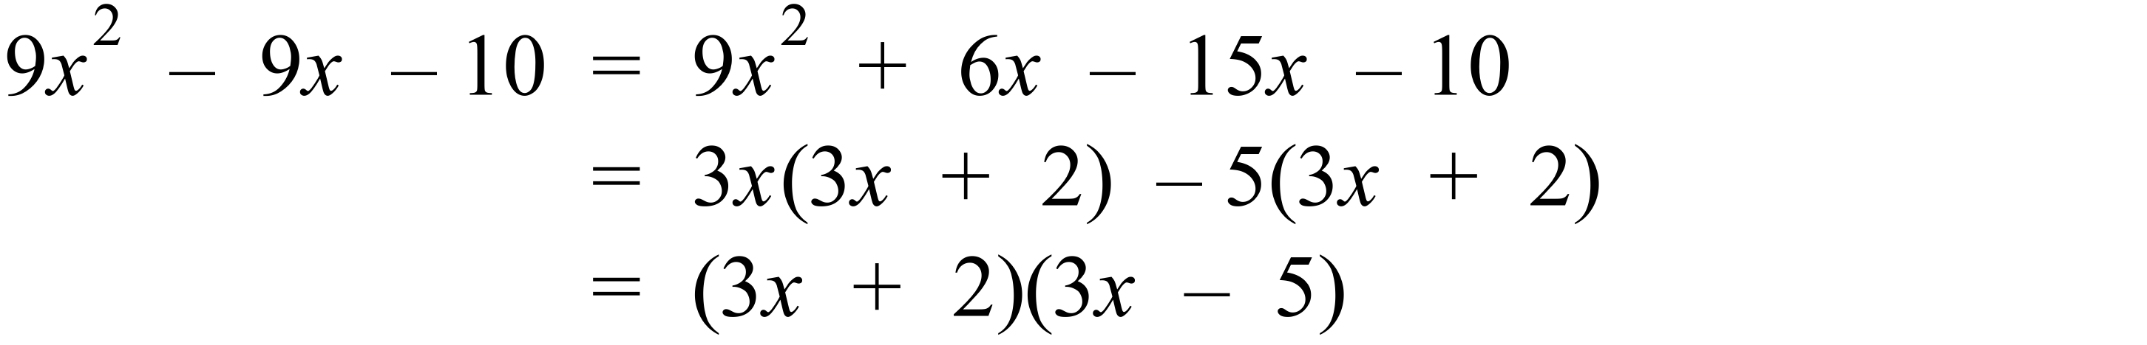 |  |  | 1 mark for correct answer
(b) | 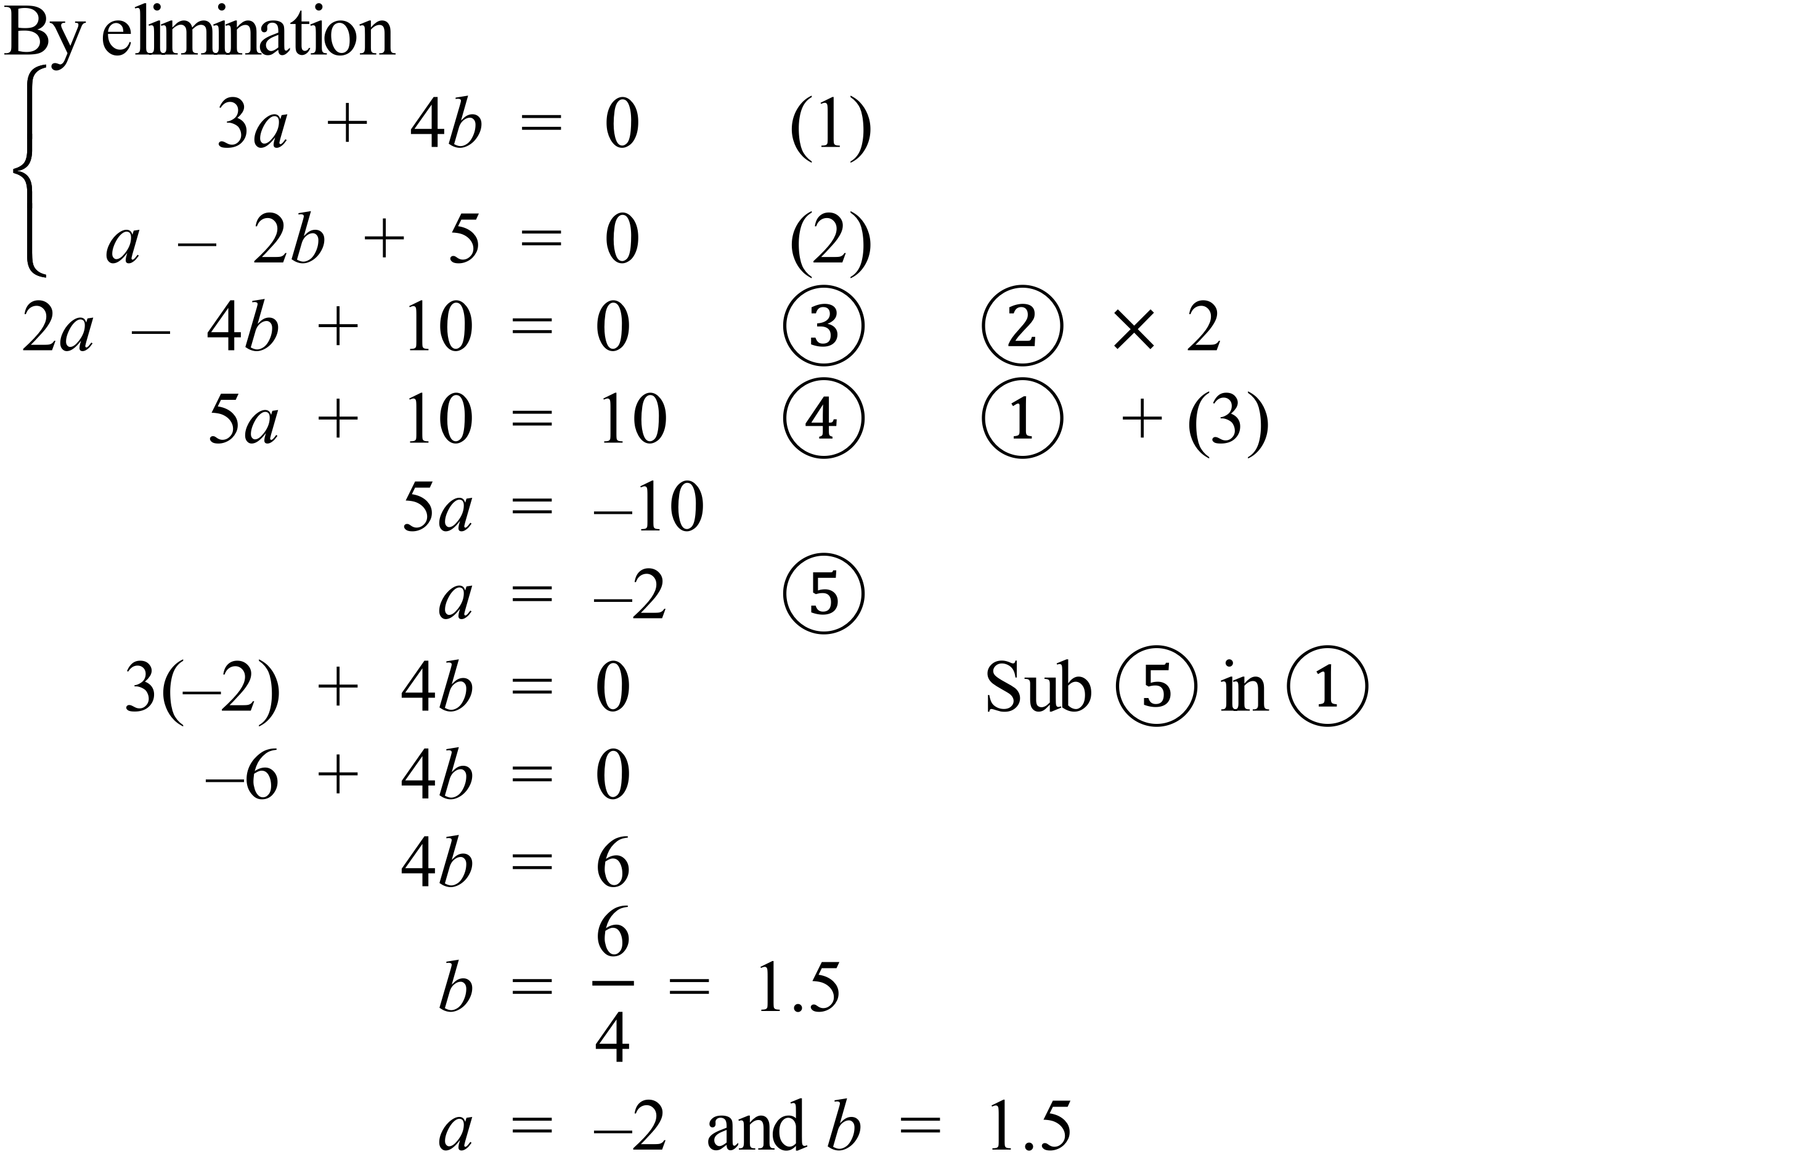  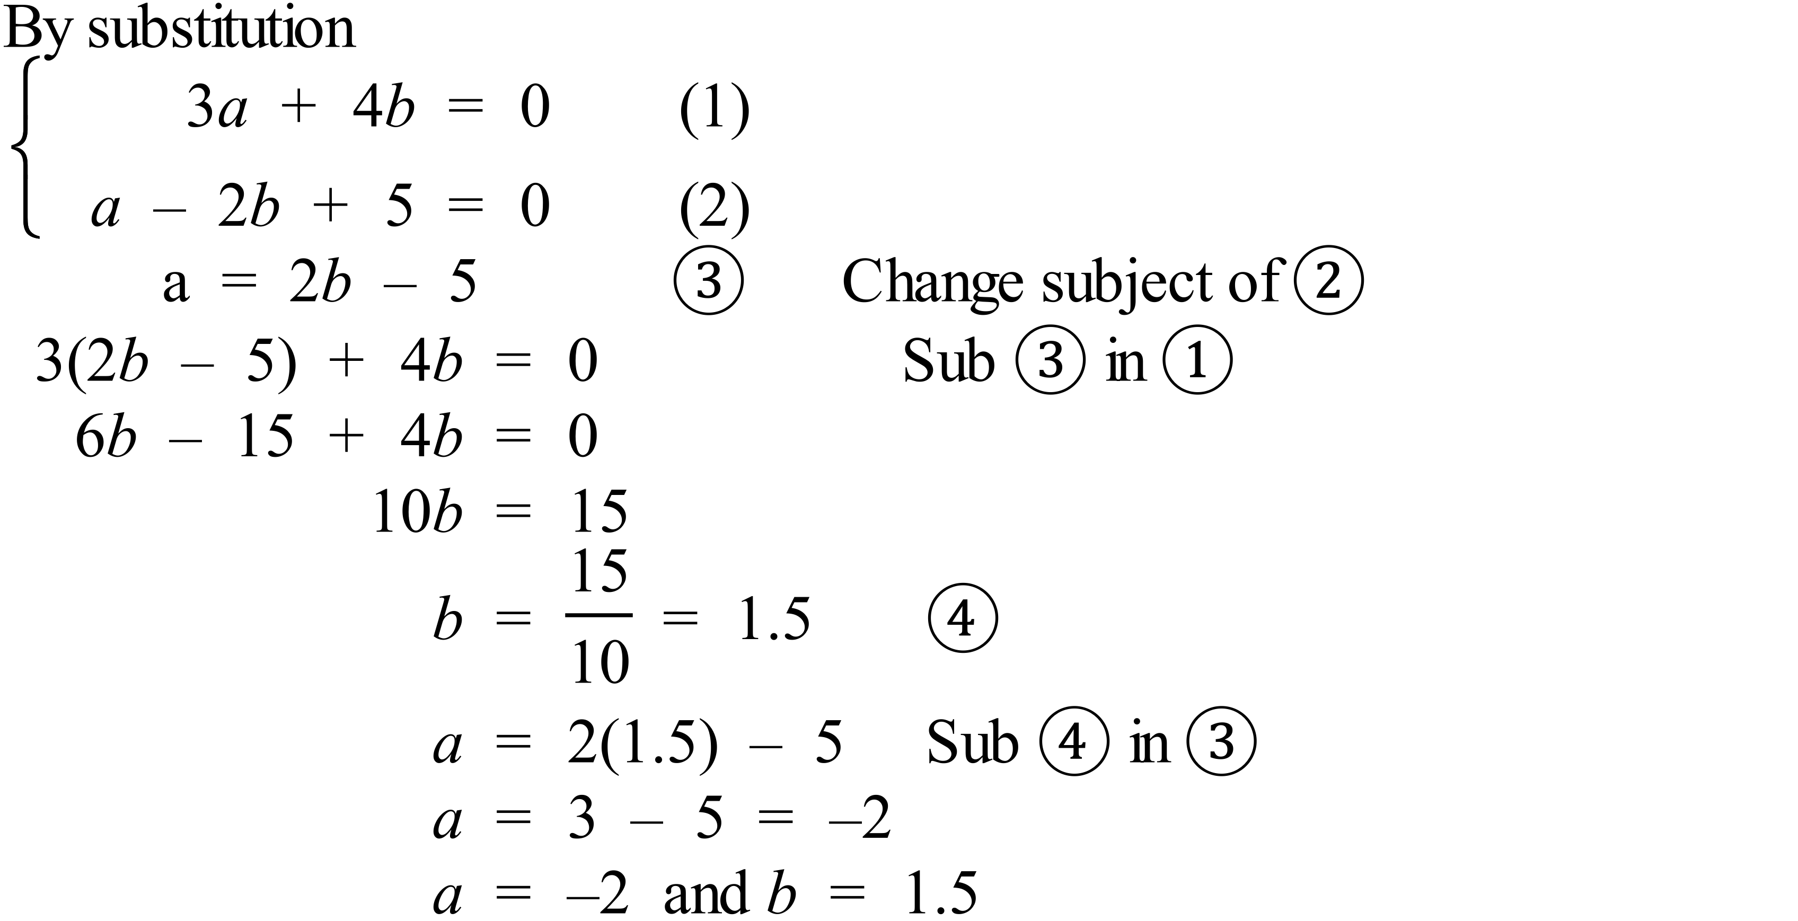 |  |  | 2 marks for correct values of a and b by either method.  Other possible working including guess, check and refine can give the result.  1 mark for worked answer with minor error(s)
78. (a) | 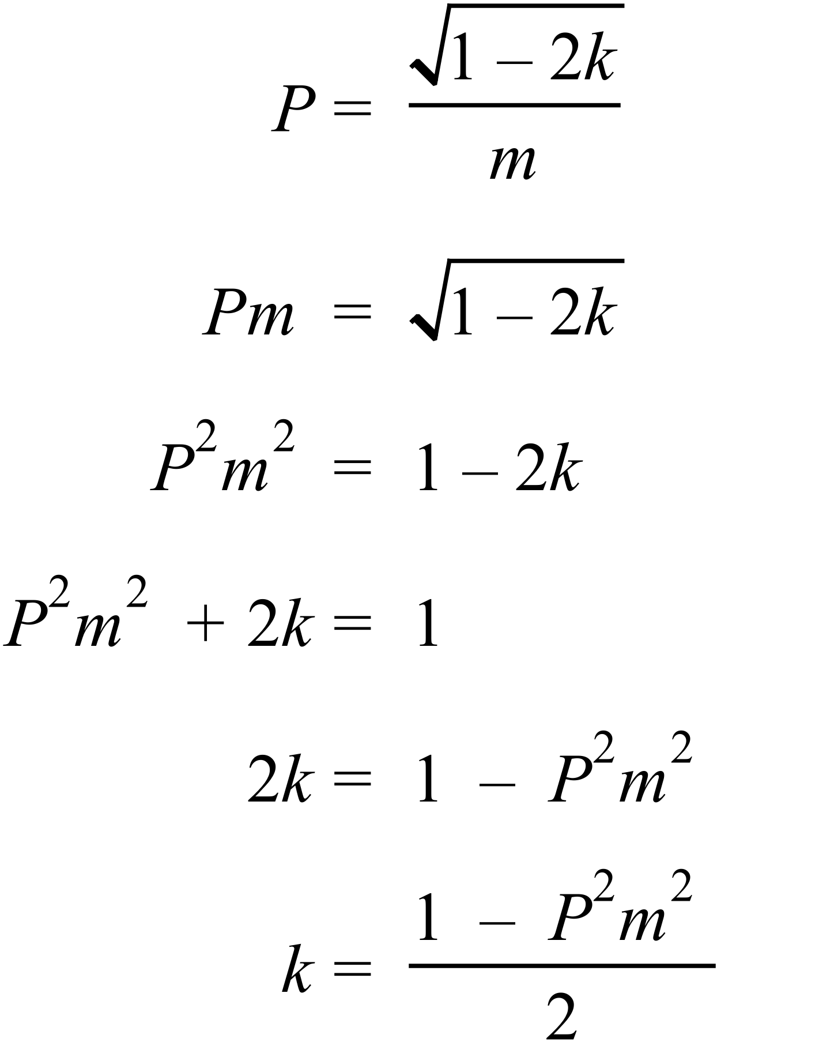 |  |  | 1 mark for correct answer
(b) | 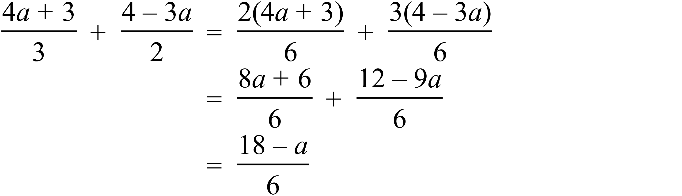 |  |  | 2 marks for correct expression.  1 mark for mainly correct worked solution with1 or 2 minor error(s) in algebra.
79. | 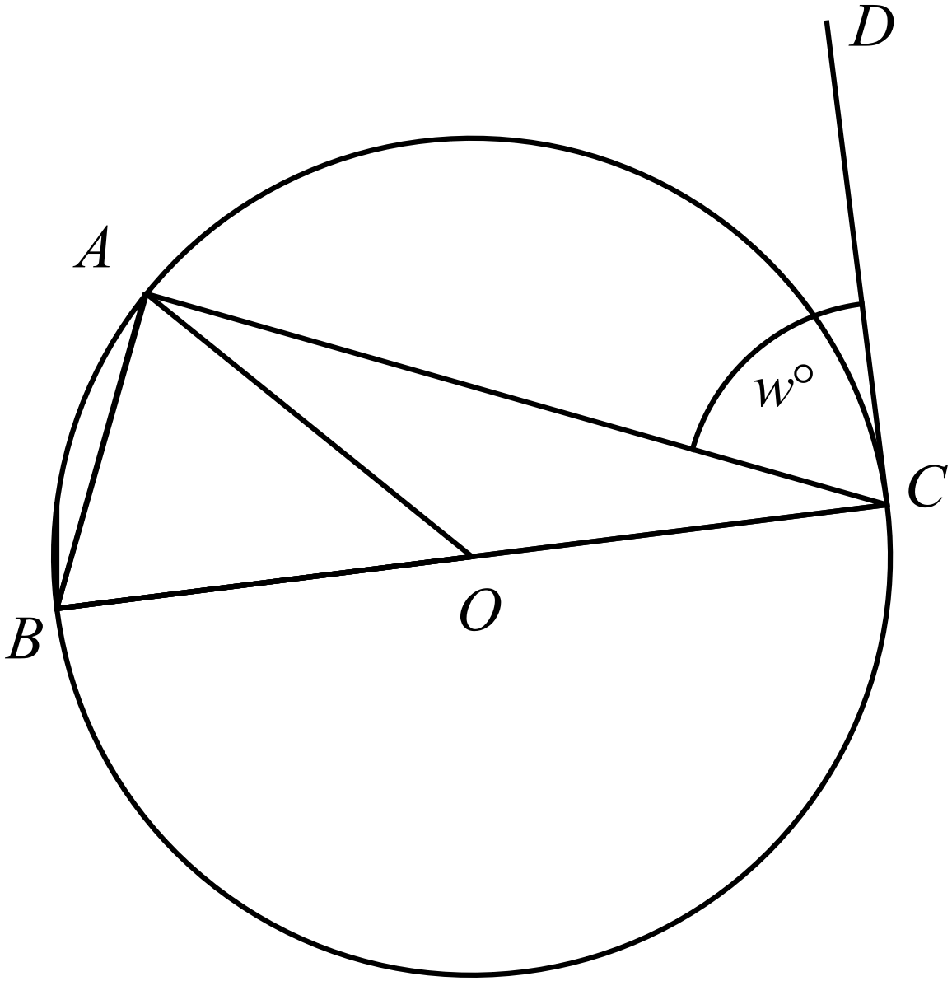  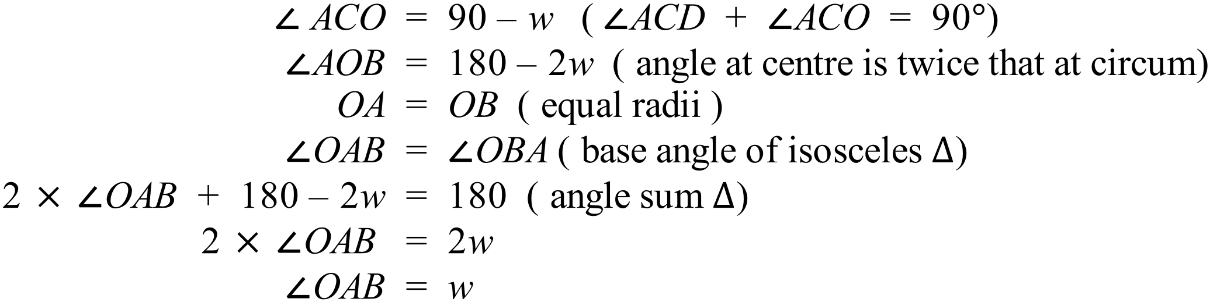 |  |  | 3 marks for any correct proof, if angle at centre property is not known it can still be done using isosceles triangles.  2 mark for basically correct proof with minor error in logic or which uses wrong reasons or is missing some reasons.  1 mark for attempt at the proof that includes at least two correct and relevant statements with reasons.
80. (a) | 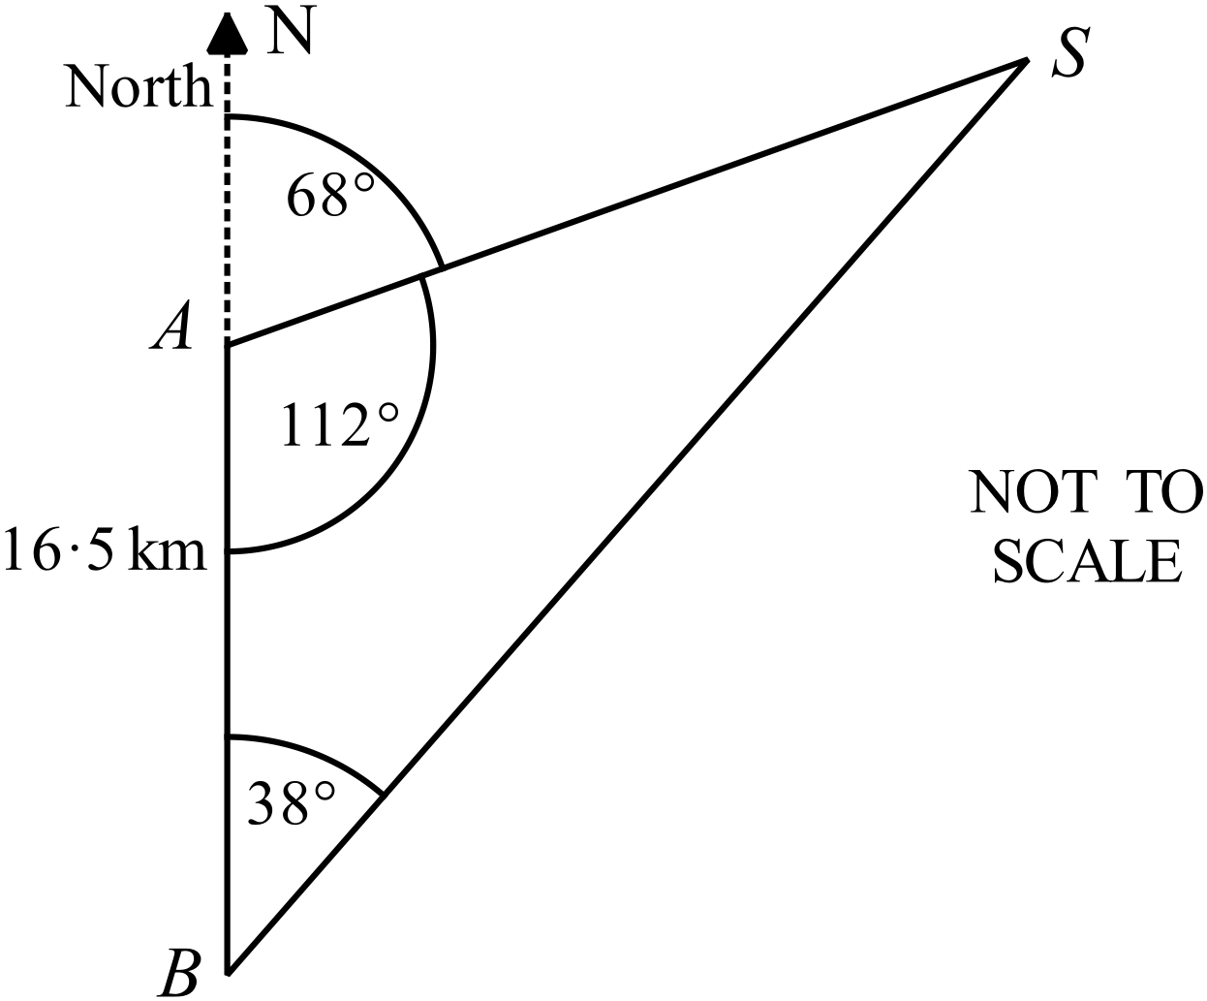  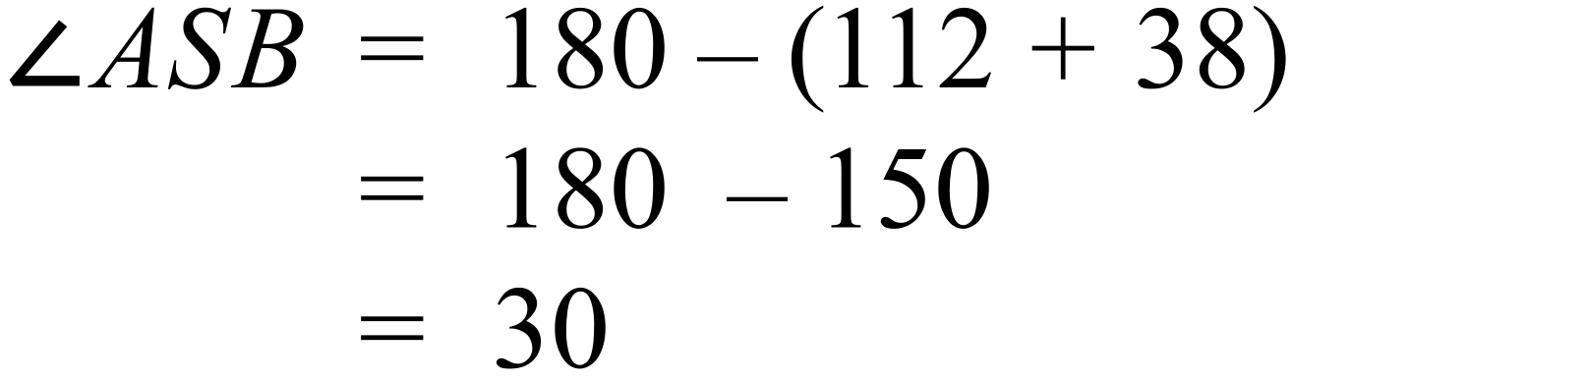 |  |  | 1 mark for correct answer
(b) | 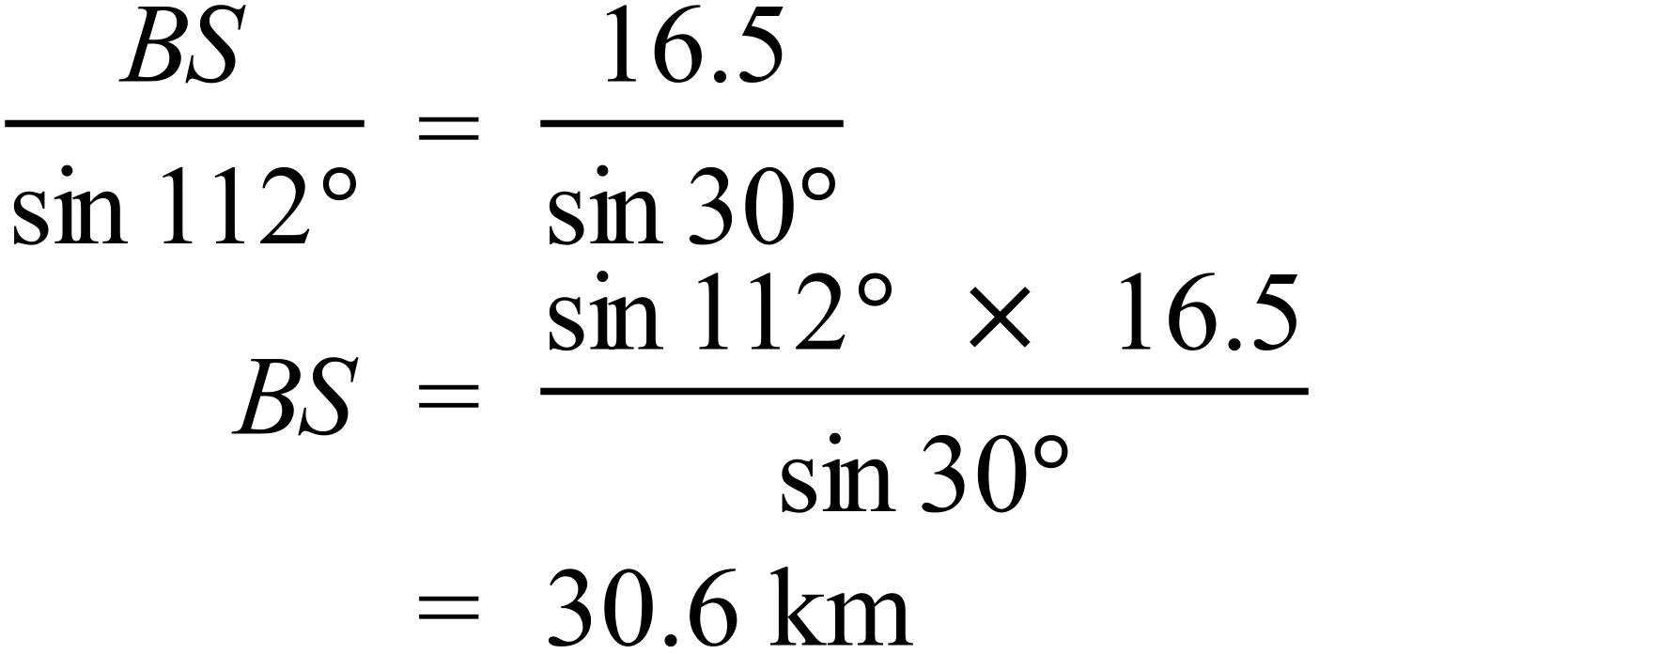 |  |  | 1 mark for correct answer
(c) | 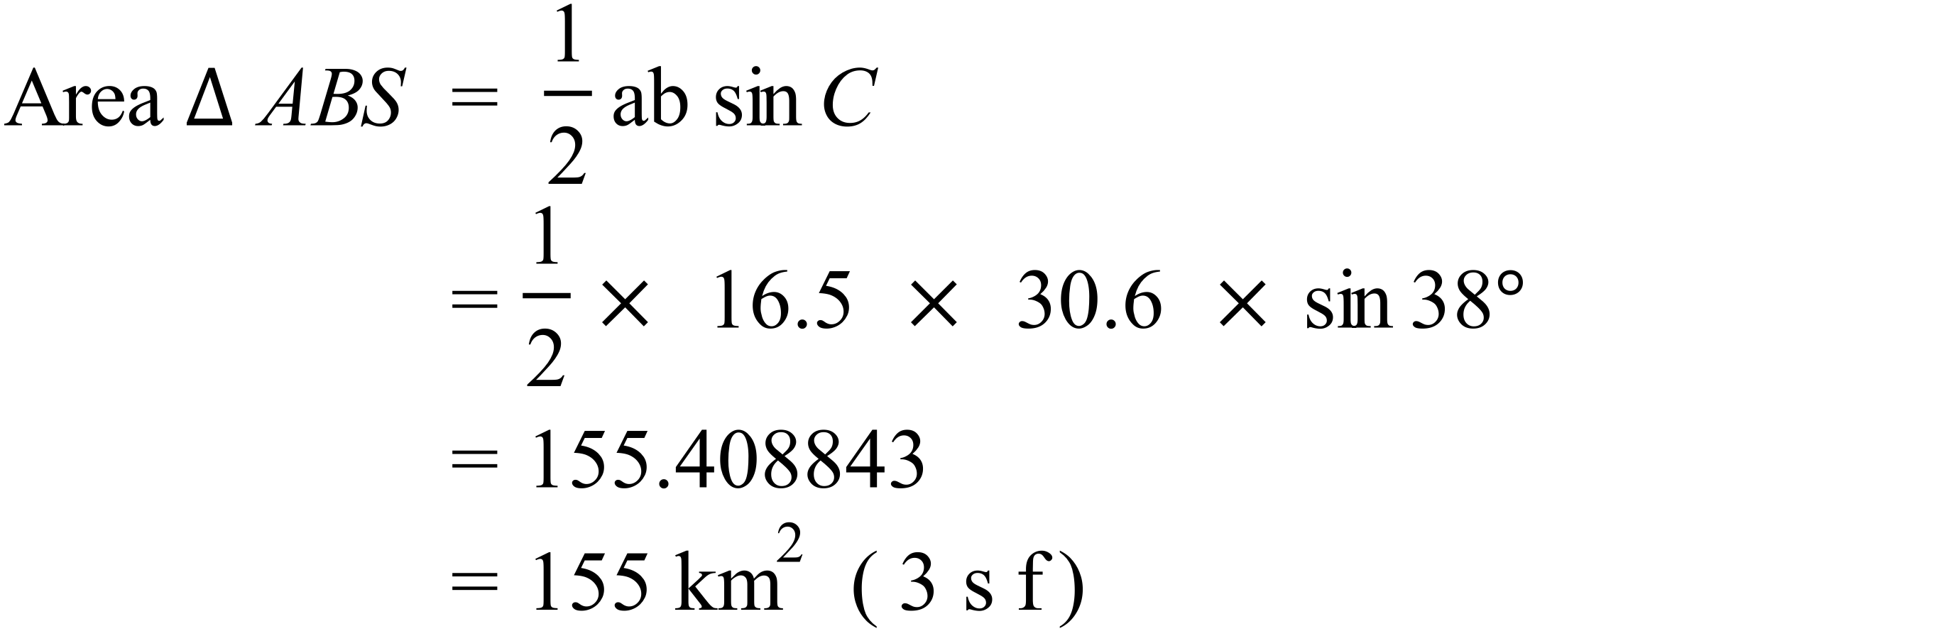 |  |  | 1 mark for correct answer
81. (a) | 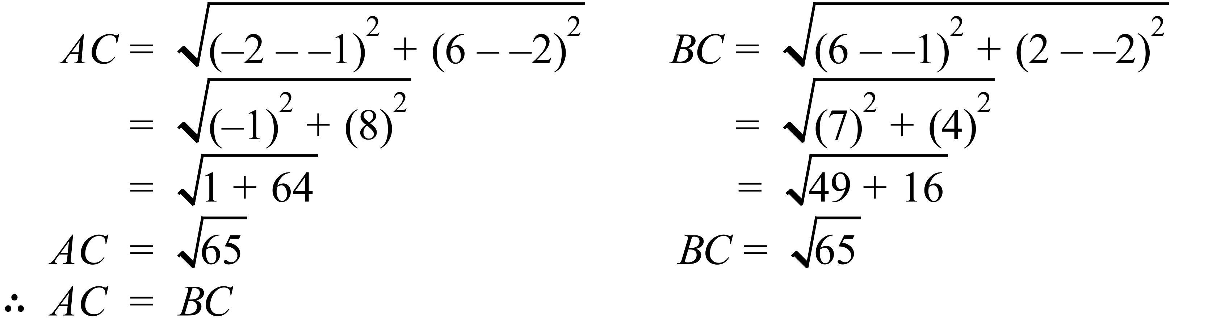 |  |  | 2 marks for correctly showing the distances are equal, using the formula or Pythagoras Theorem  1 mark for a worked solution with a minor error or which shows some progress toward correct solution.
(b) | 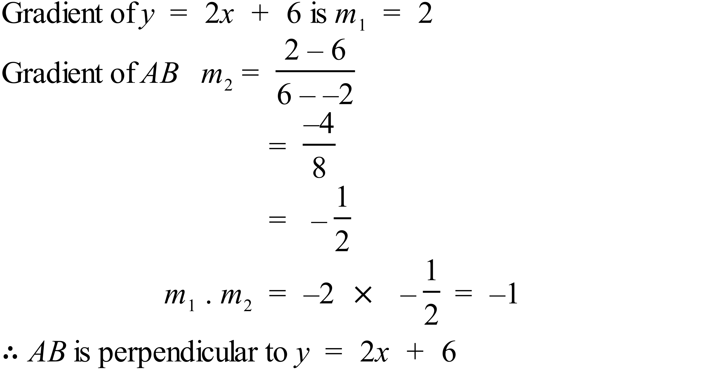 |  |  | 2 marks for correctly finding the gradients and showing their product is 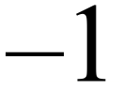  1 mark for a worked solution with a minor error or which shows some progress toward correct solution.

82. (a) | 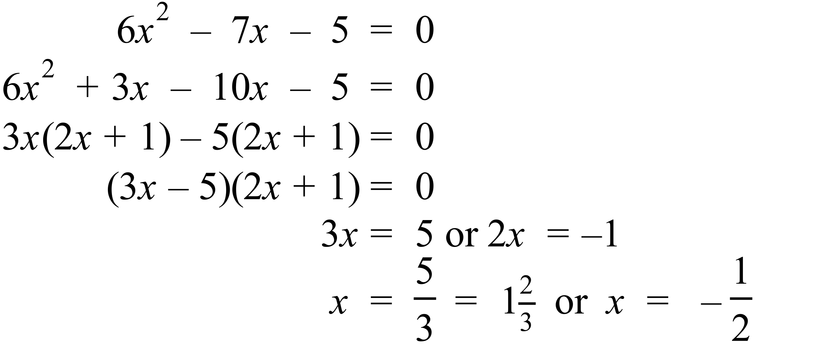. | 1 mark for both correct answers.
(b) | 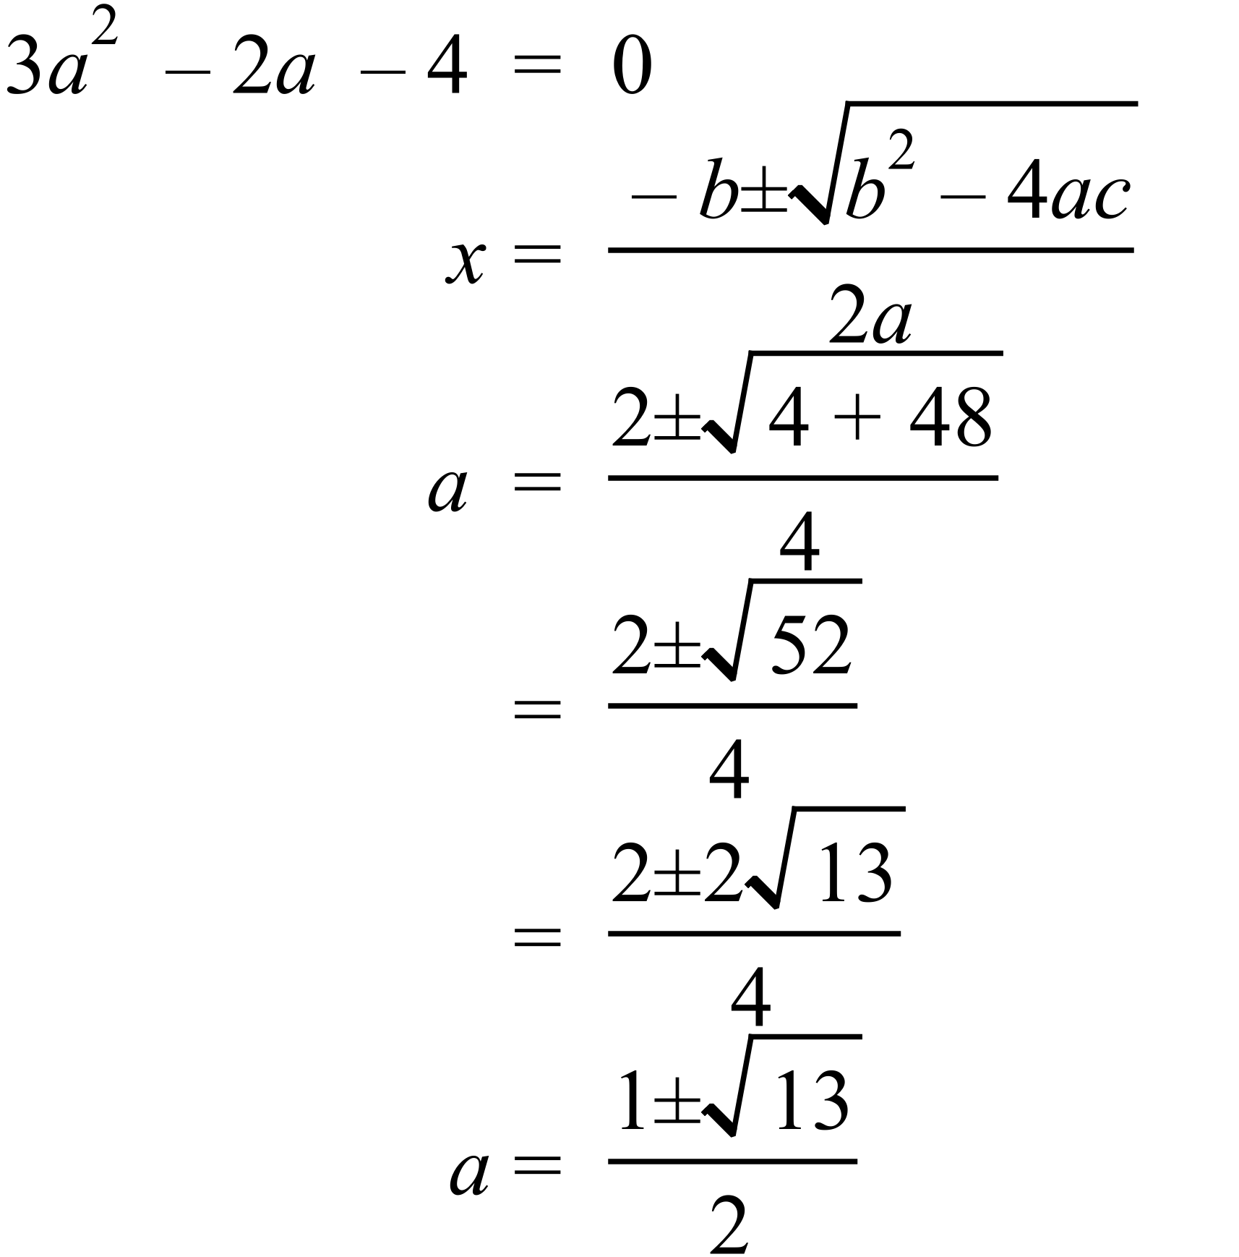 | 2 marks for correct answer in simplified form  1 mark for answer found using Quadratic Formula or completing the square which has a minor error or is not simplified correctly
83. (a) | 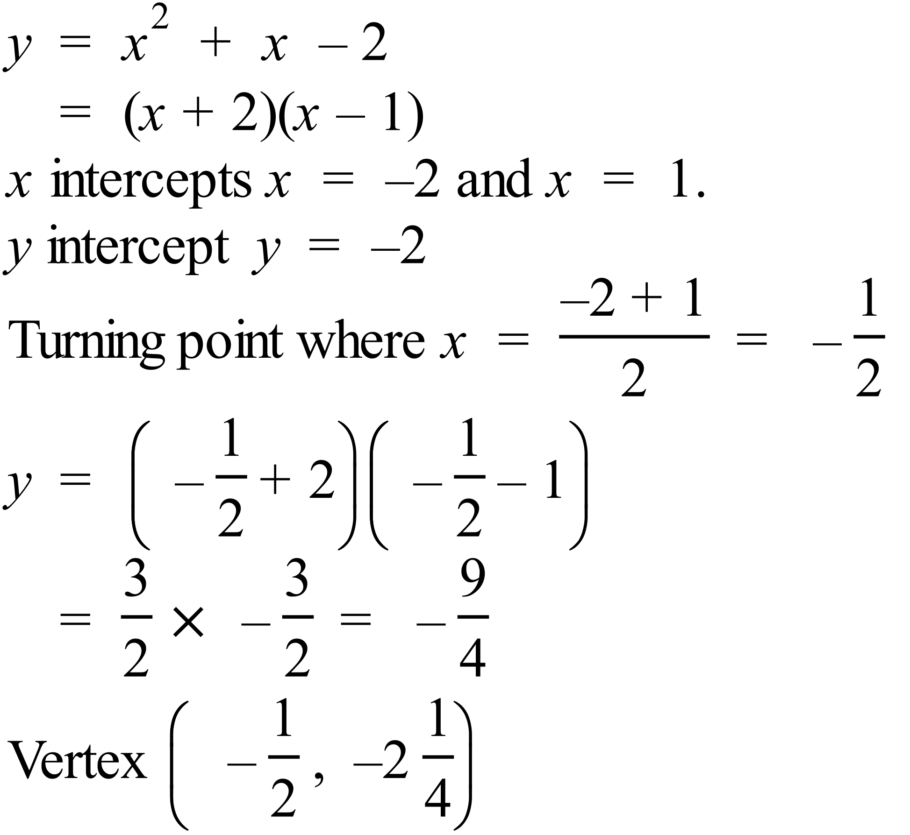.  Graph  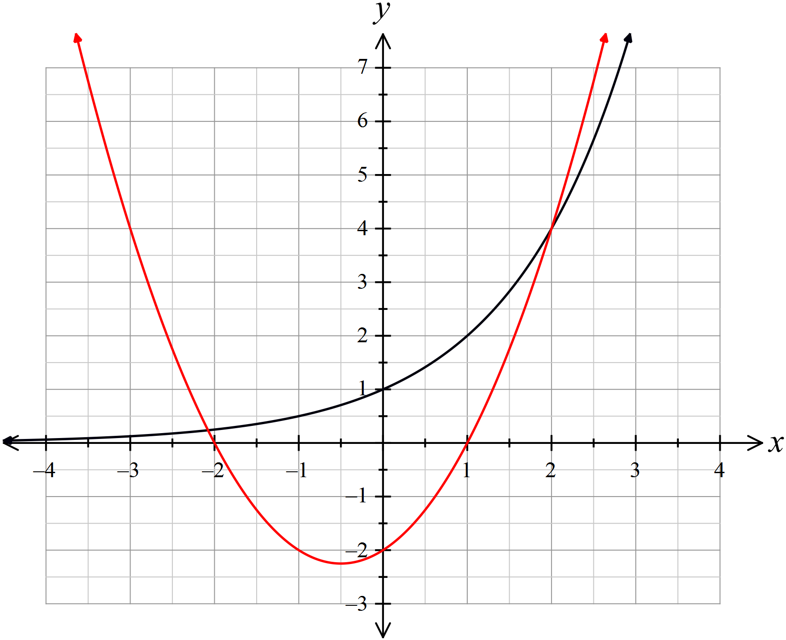 | 2 marks for correct graph including the correct intercepts, and vertex in correct x position, (exact y value not needed)  1 mark for a graph which is inaccurately drawn, has a minor error in intercepts or which is incomplete.
(b) | The points of intersection have x values which correspond to the solution of the equation 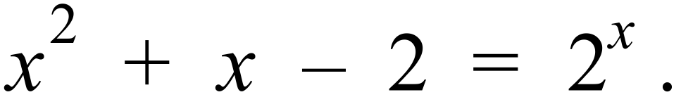  These values are approximately | 1 mark if both answers given.

